<https://www.oracle.com/cloud/sign-in.html>

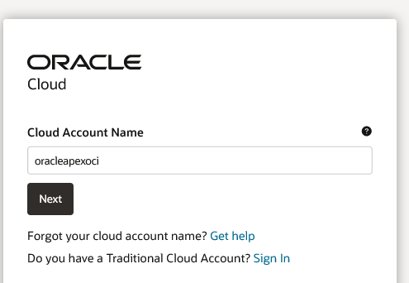

Oracleapexoci

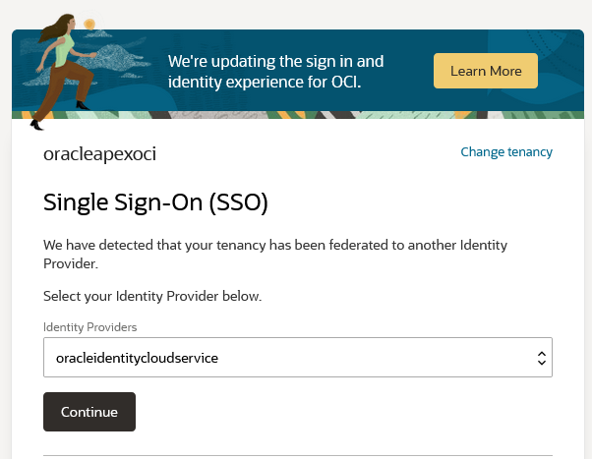

Oracleidentitycloudservice

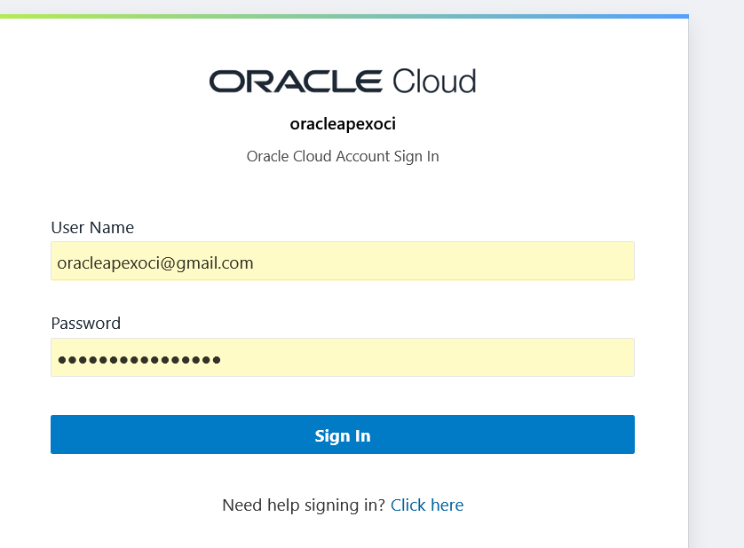

[oracleapexoci@gmail.com](mailto:oracleapexoci@gmail.com) / Epfy44yqE_MISO1!

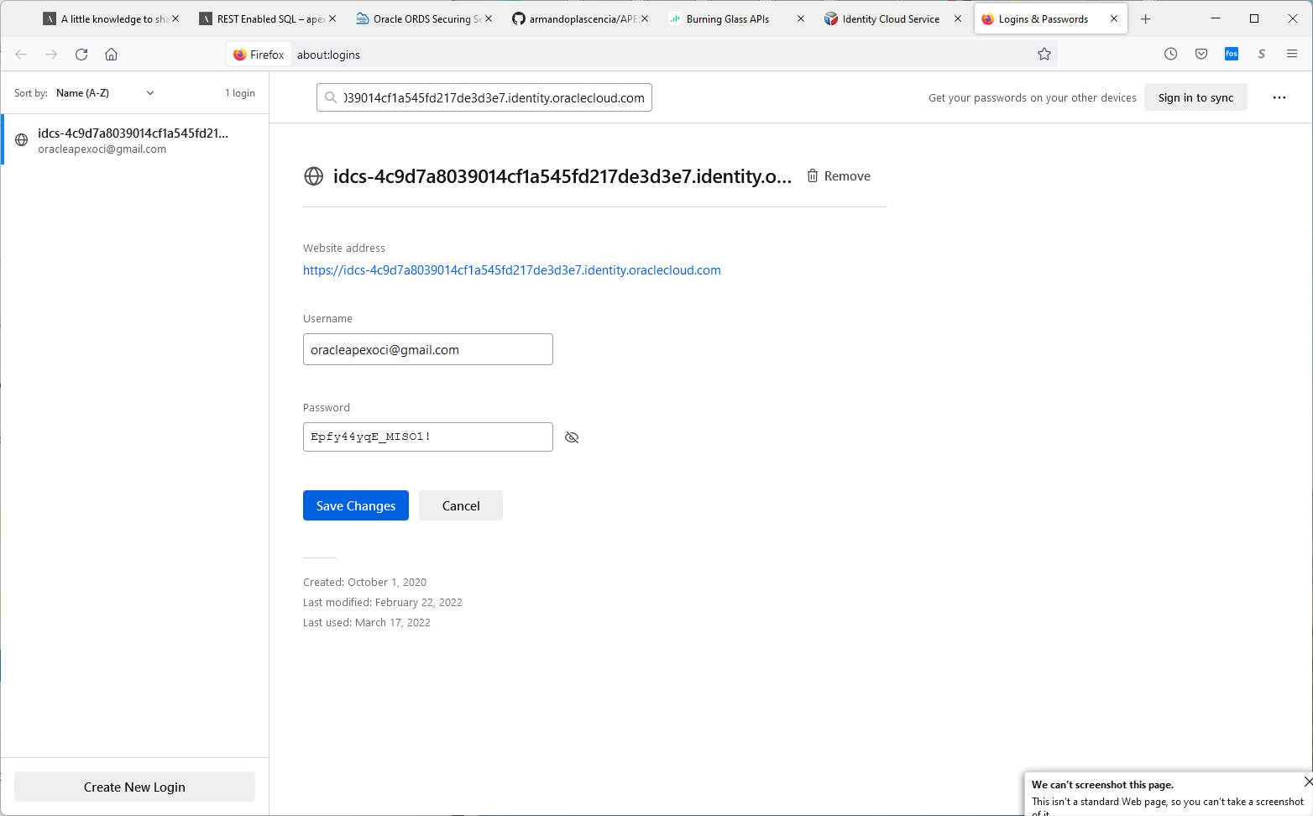

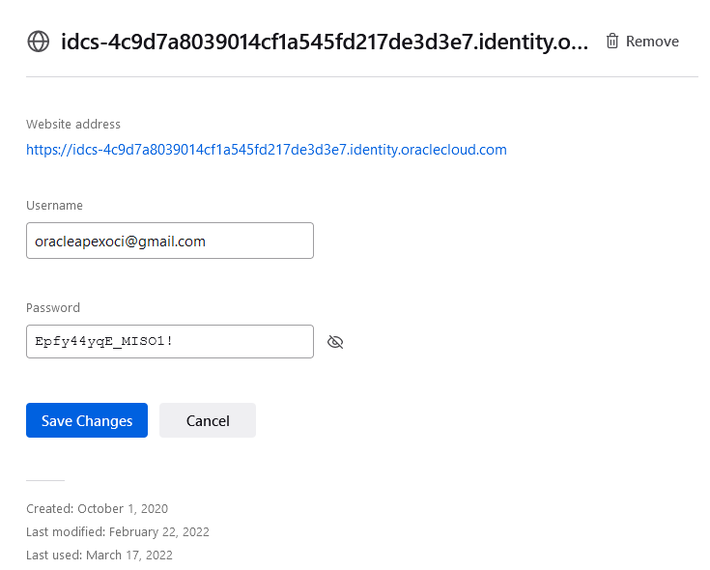

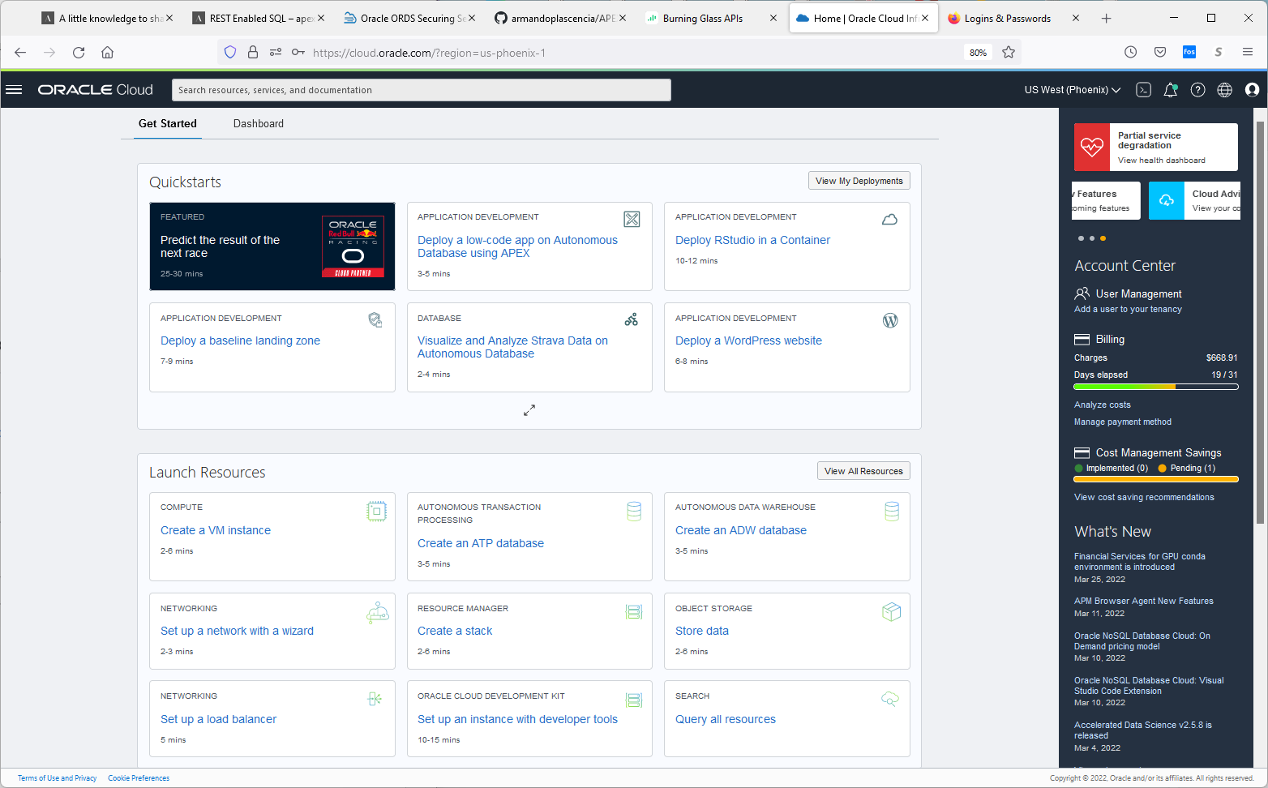

Click on burgers. To the top left of the oracle Cloud label, left of search field.

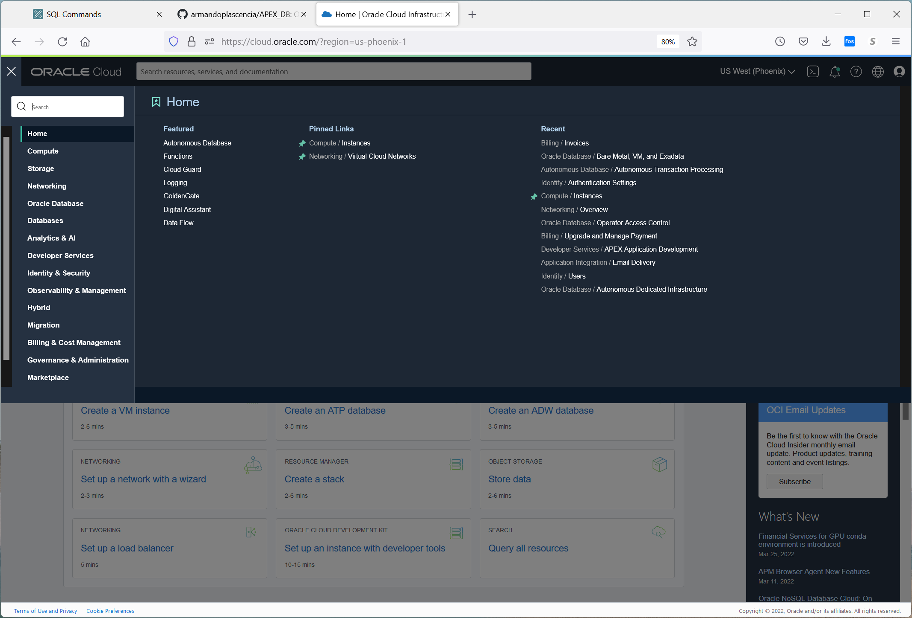

Click on autonomous database under featured under home.

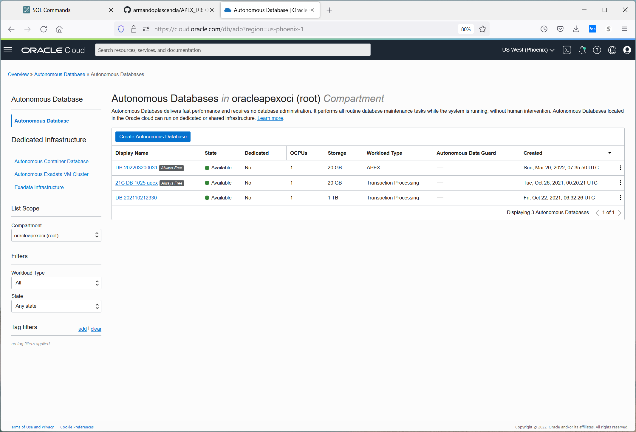

Clink on the [DB 202110212330](https://cloud.oracle.com/db/adb/ocid1.autonomousdatabase.oc1.phx.anyhqljsx7hjfgqaog5qywzjmdtaiqjtqpns5jxdxv4gvqvbyajucqdvo7hq) link

The other two are demo sites and zero cost.

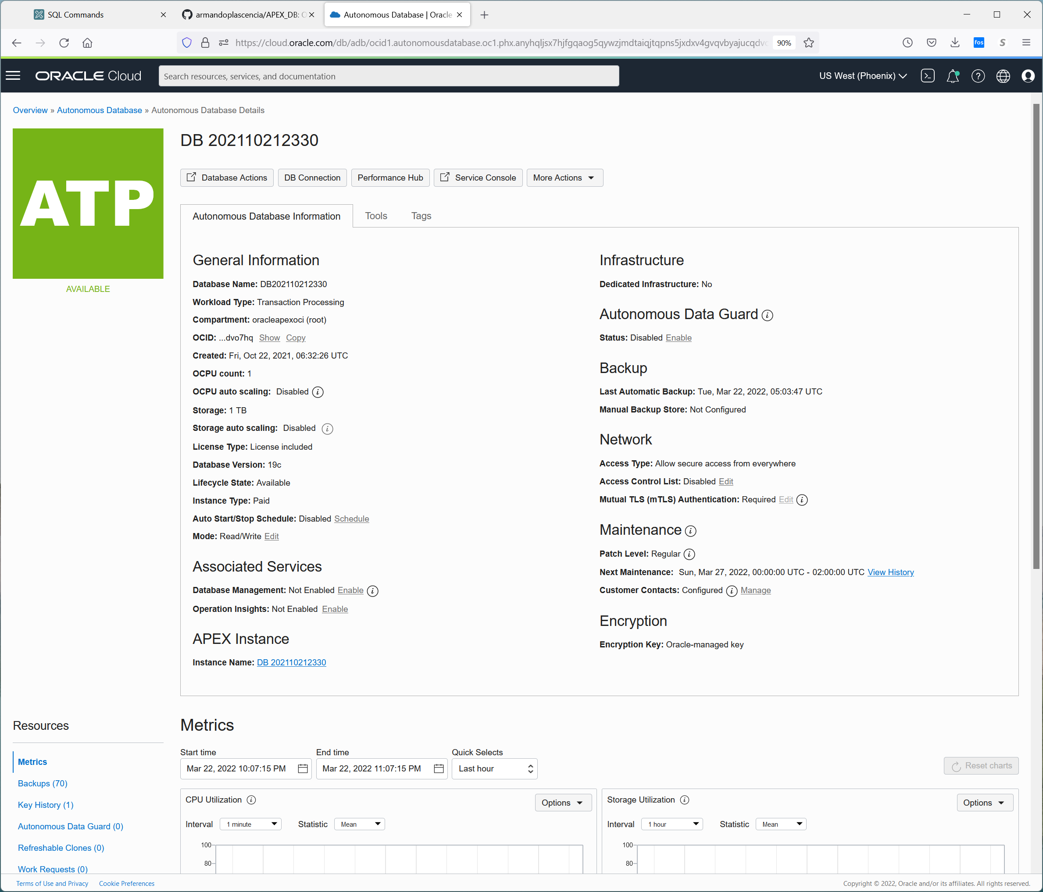

Under tools

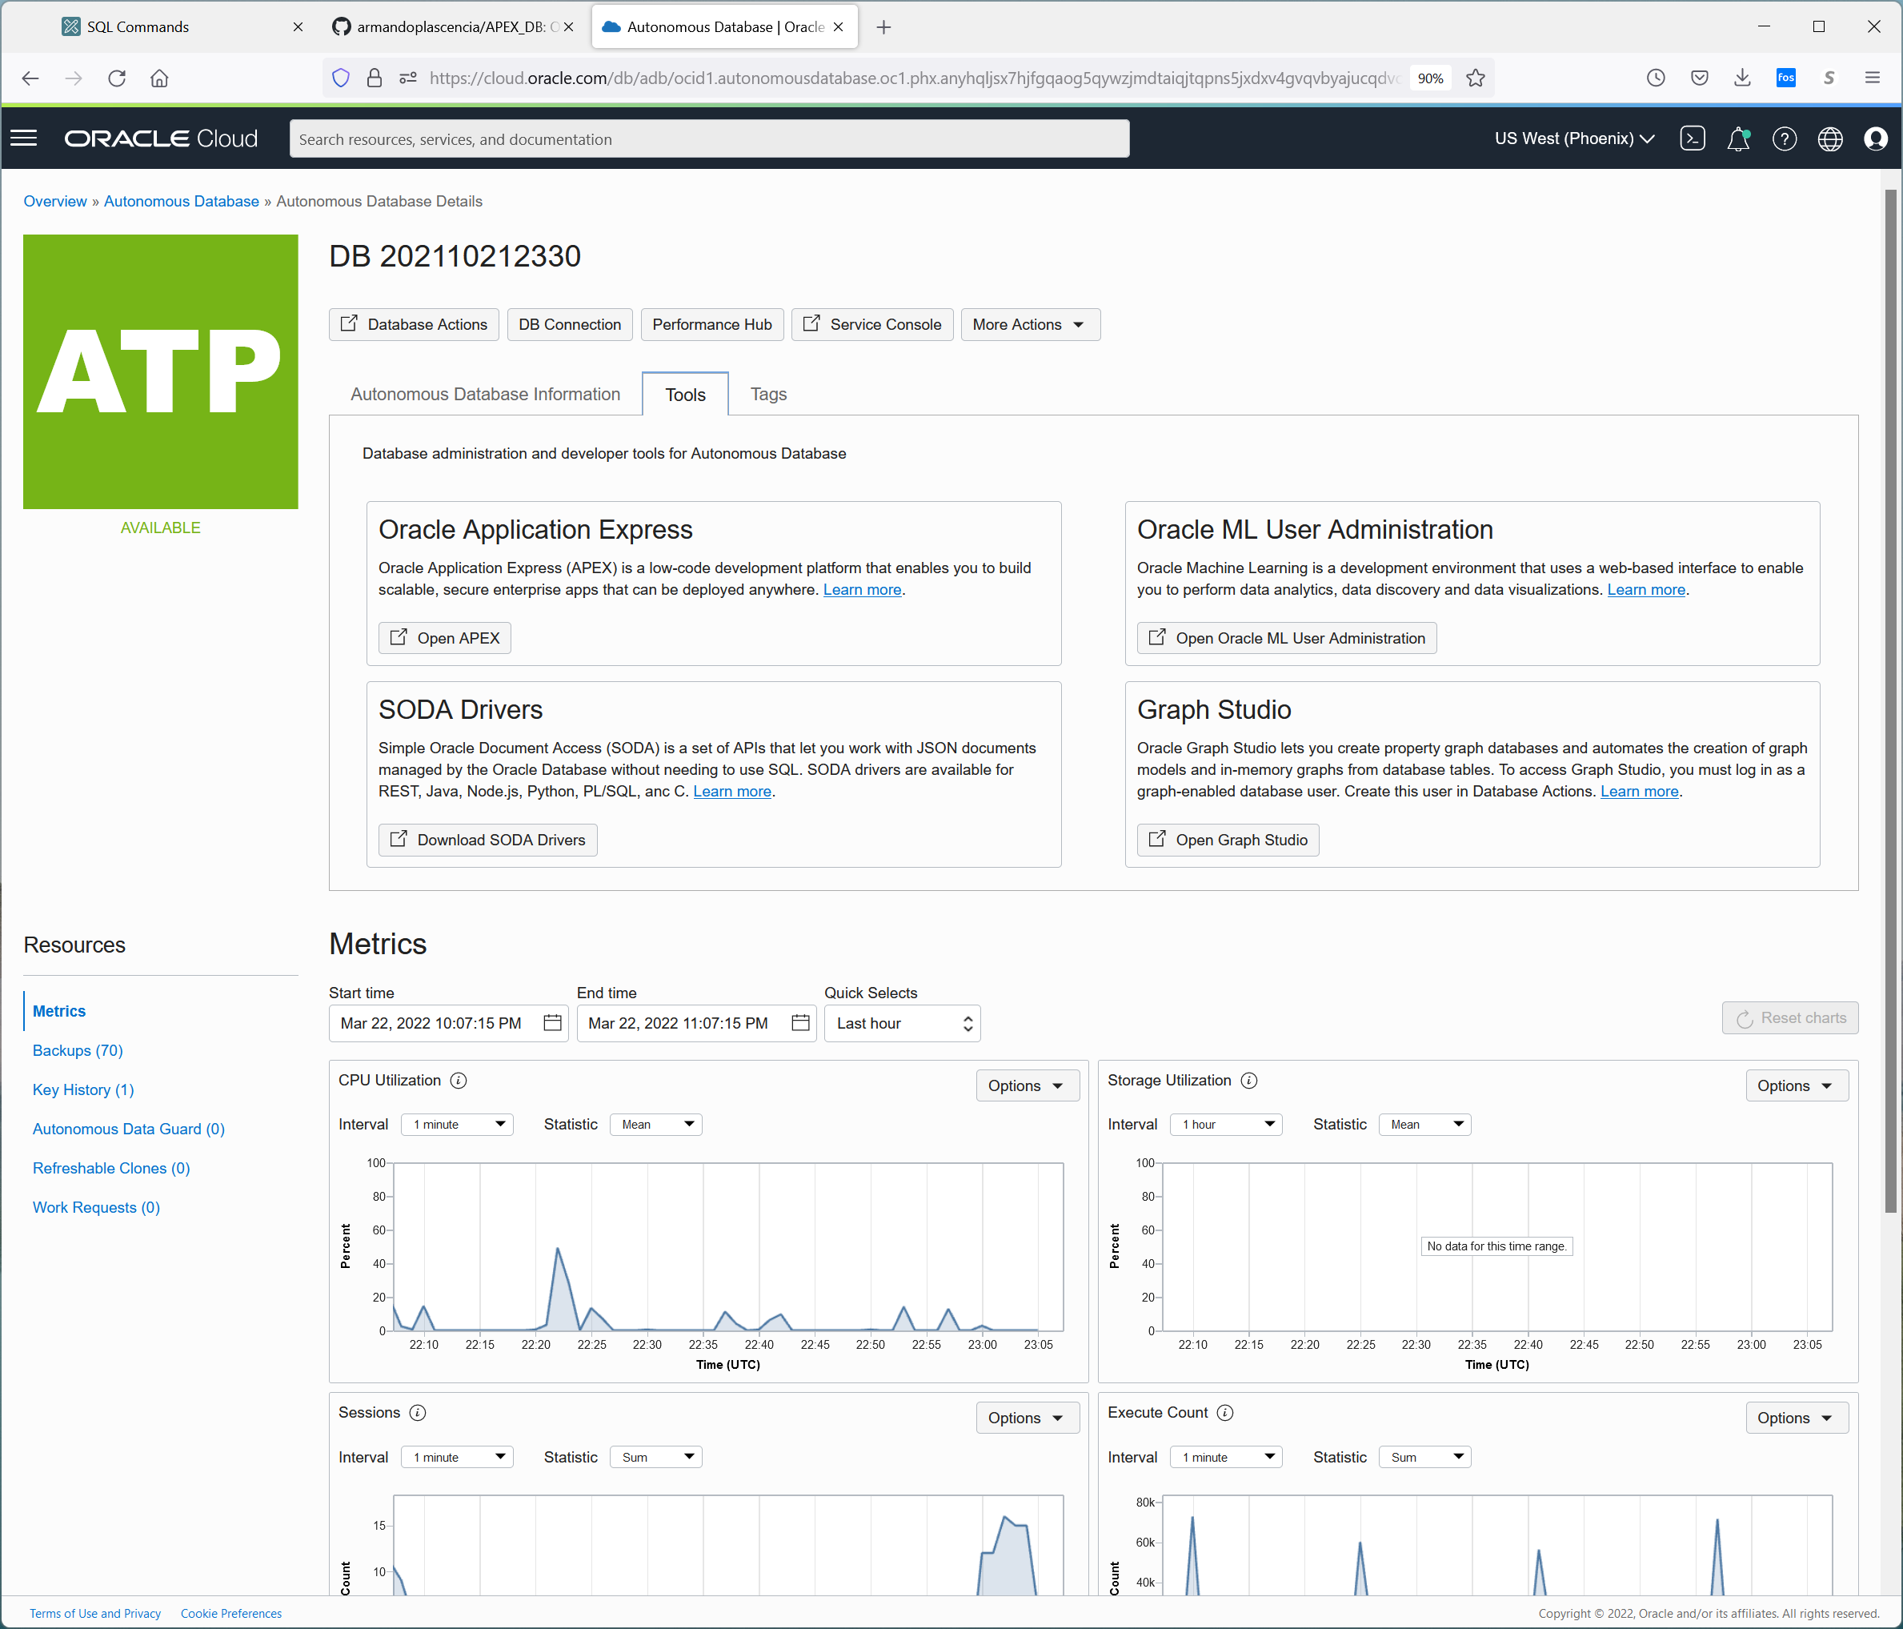

Under tags

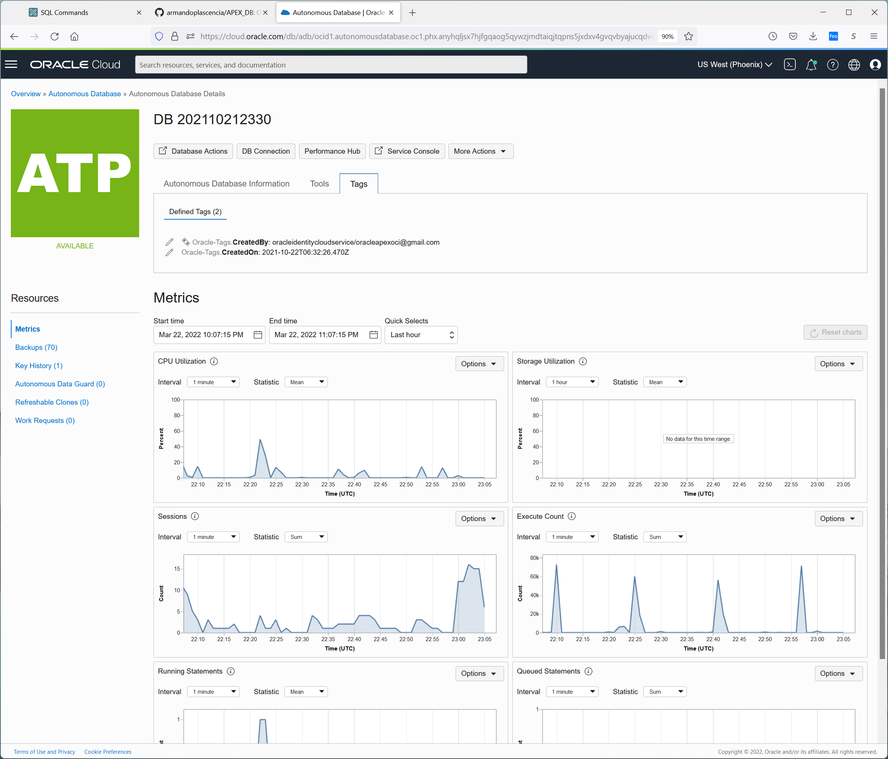

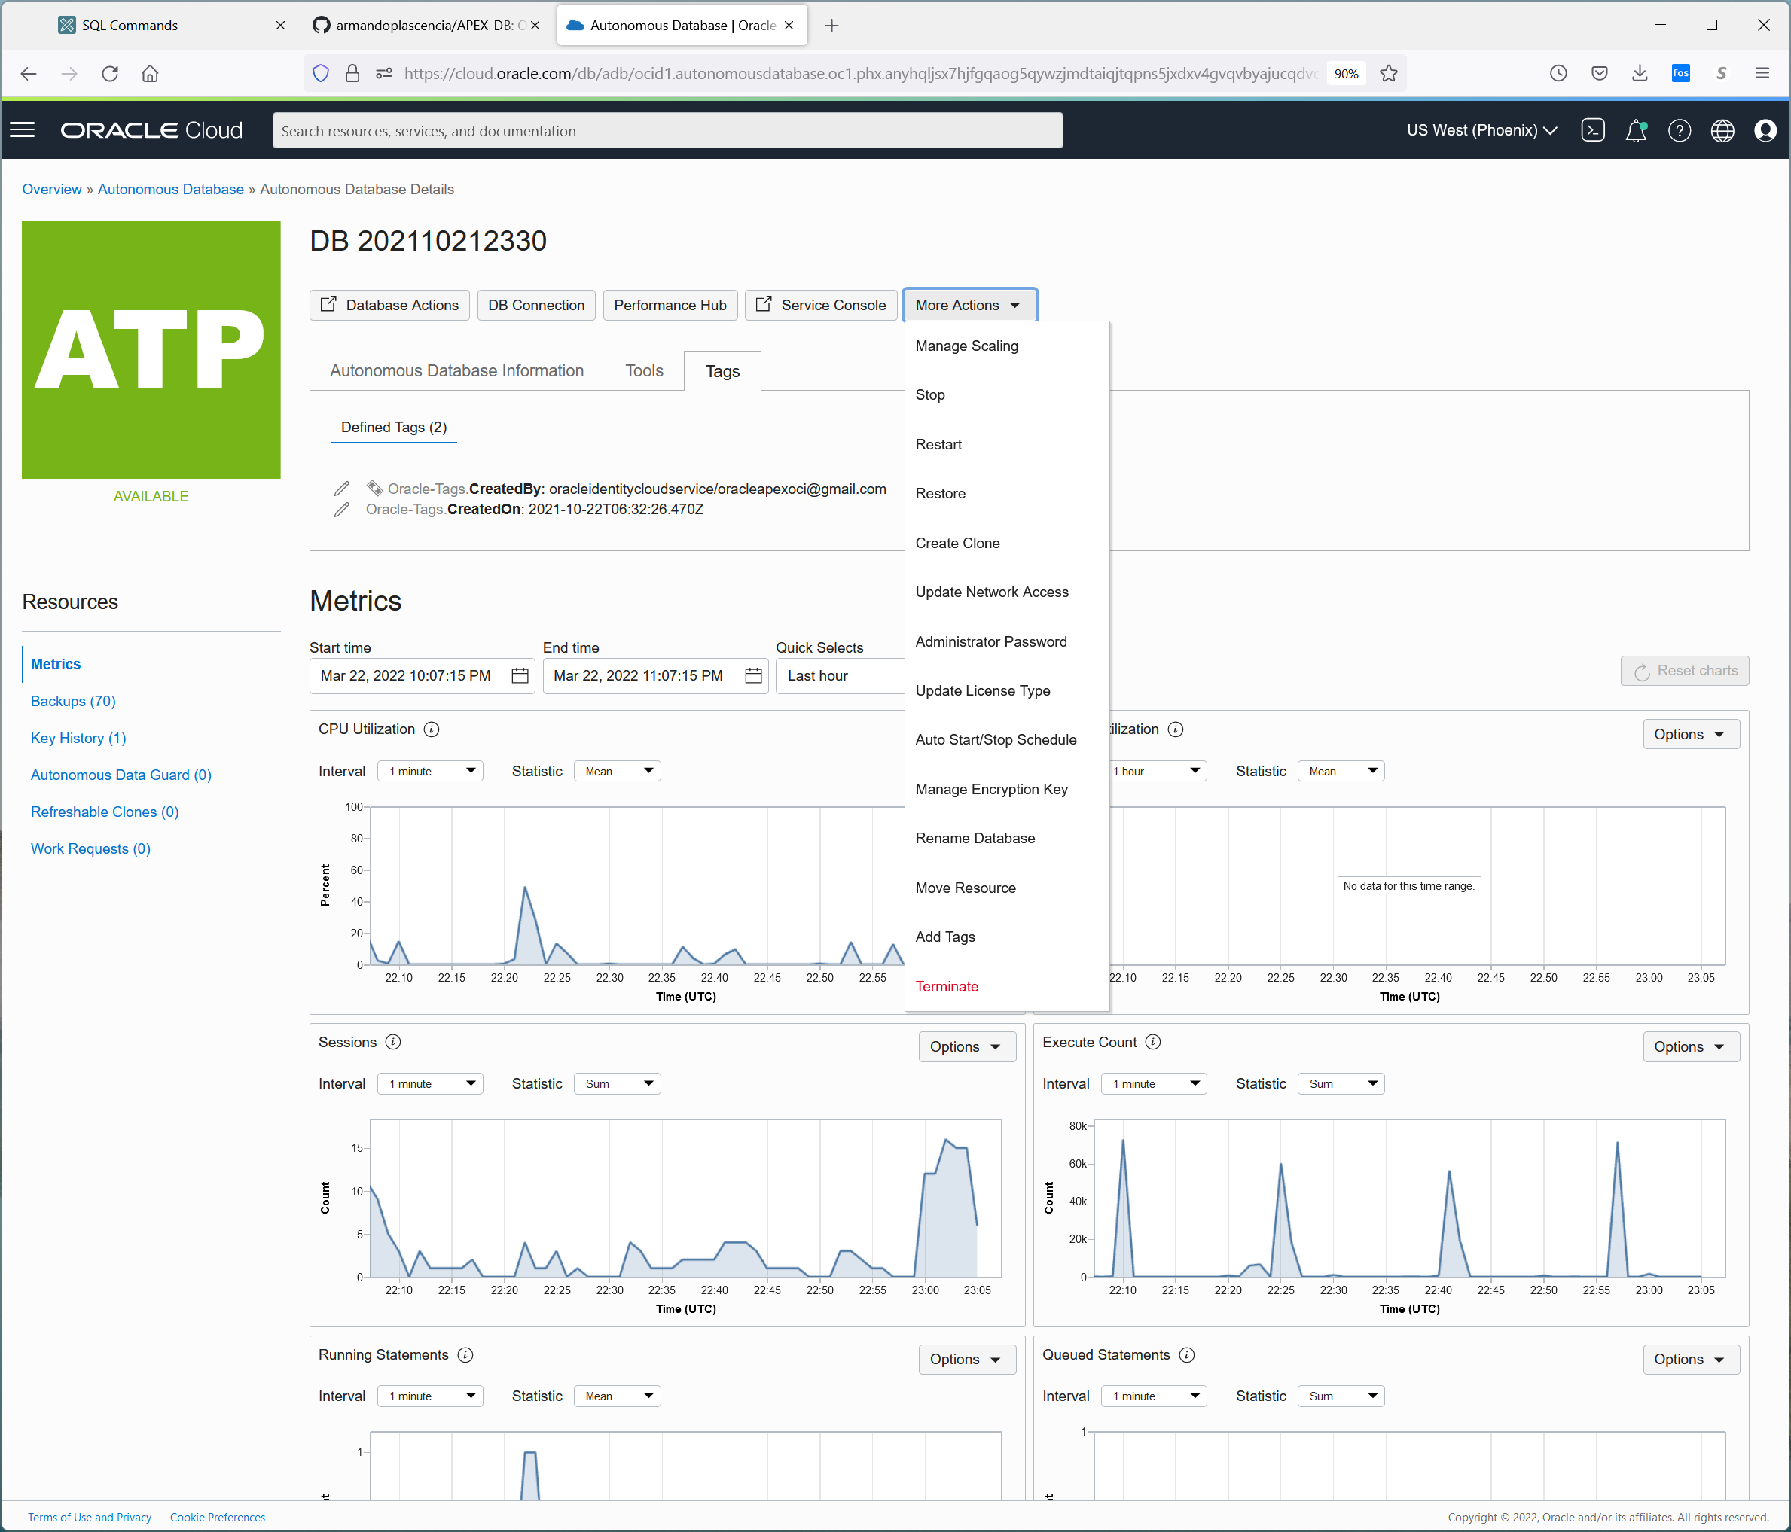

Keys to database connections are here undre DB Connections

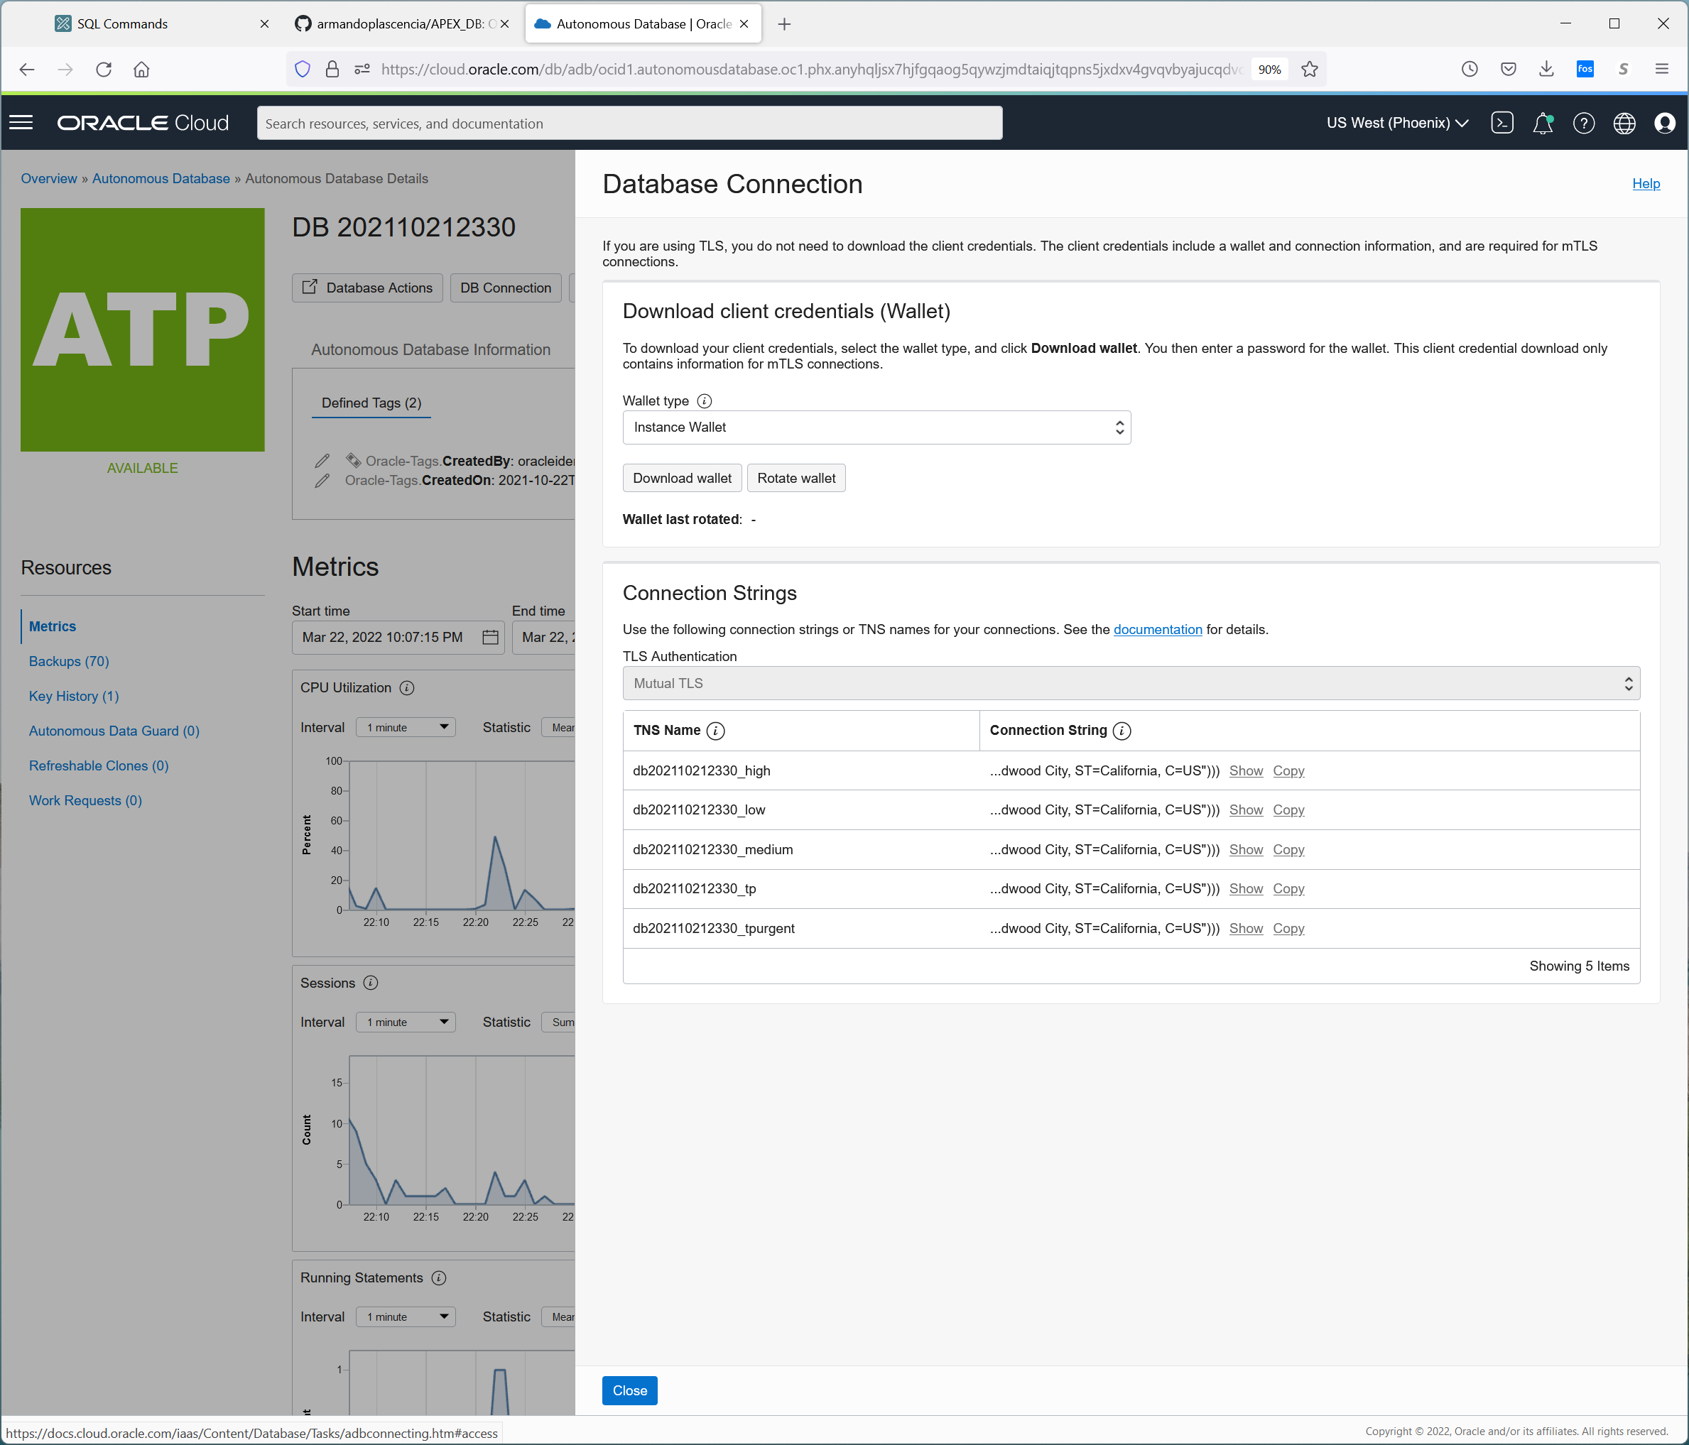

Under Database Actions

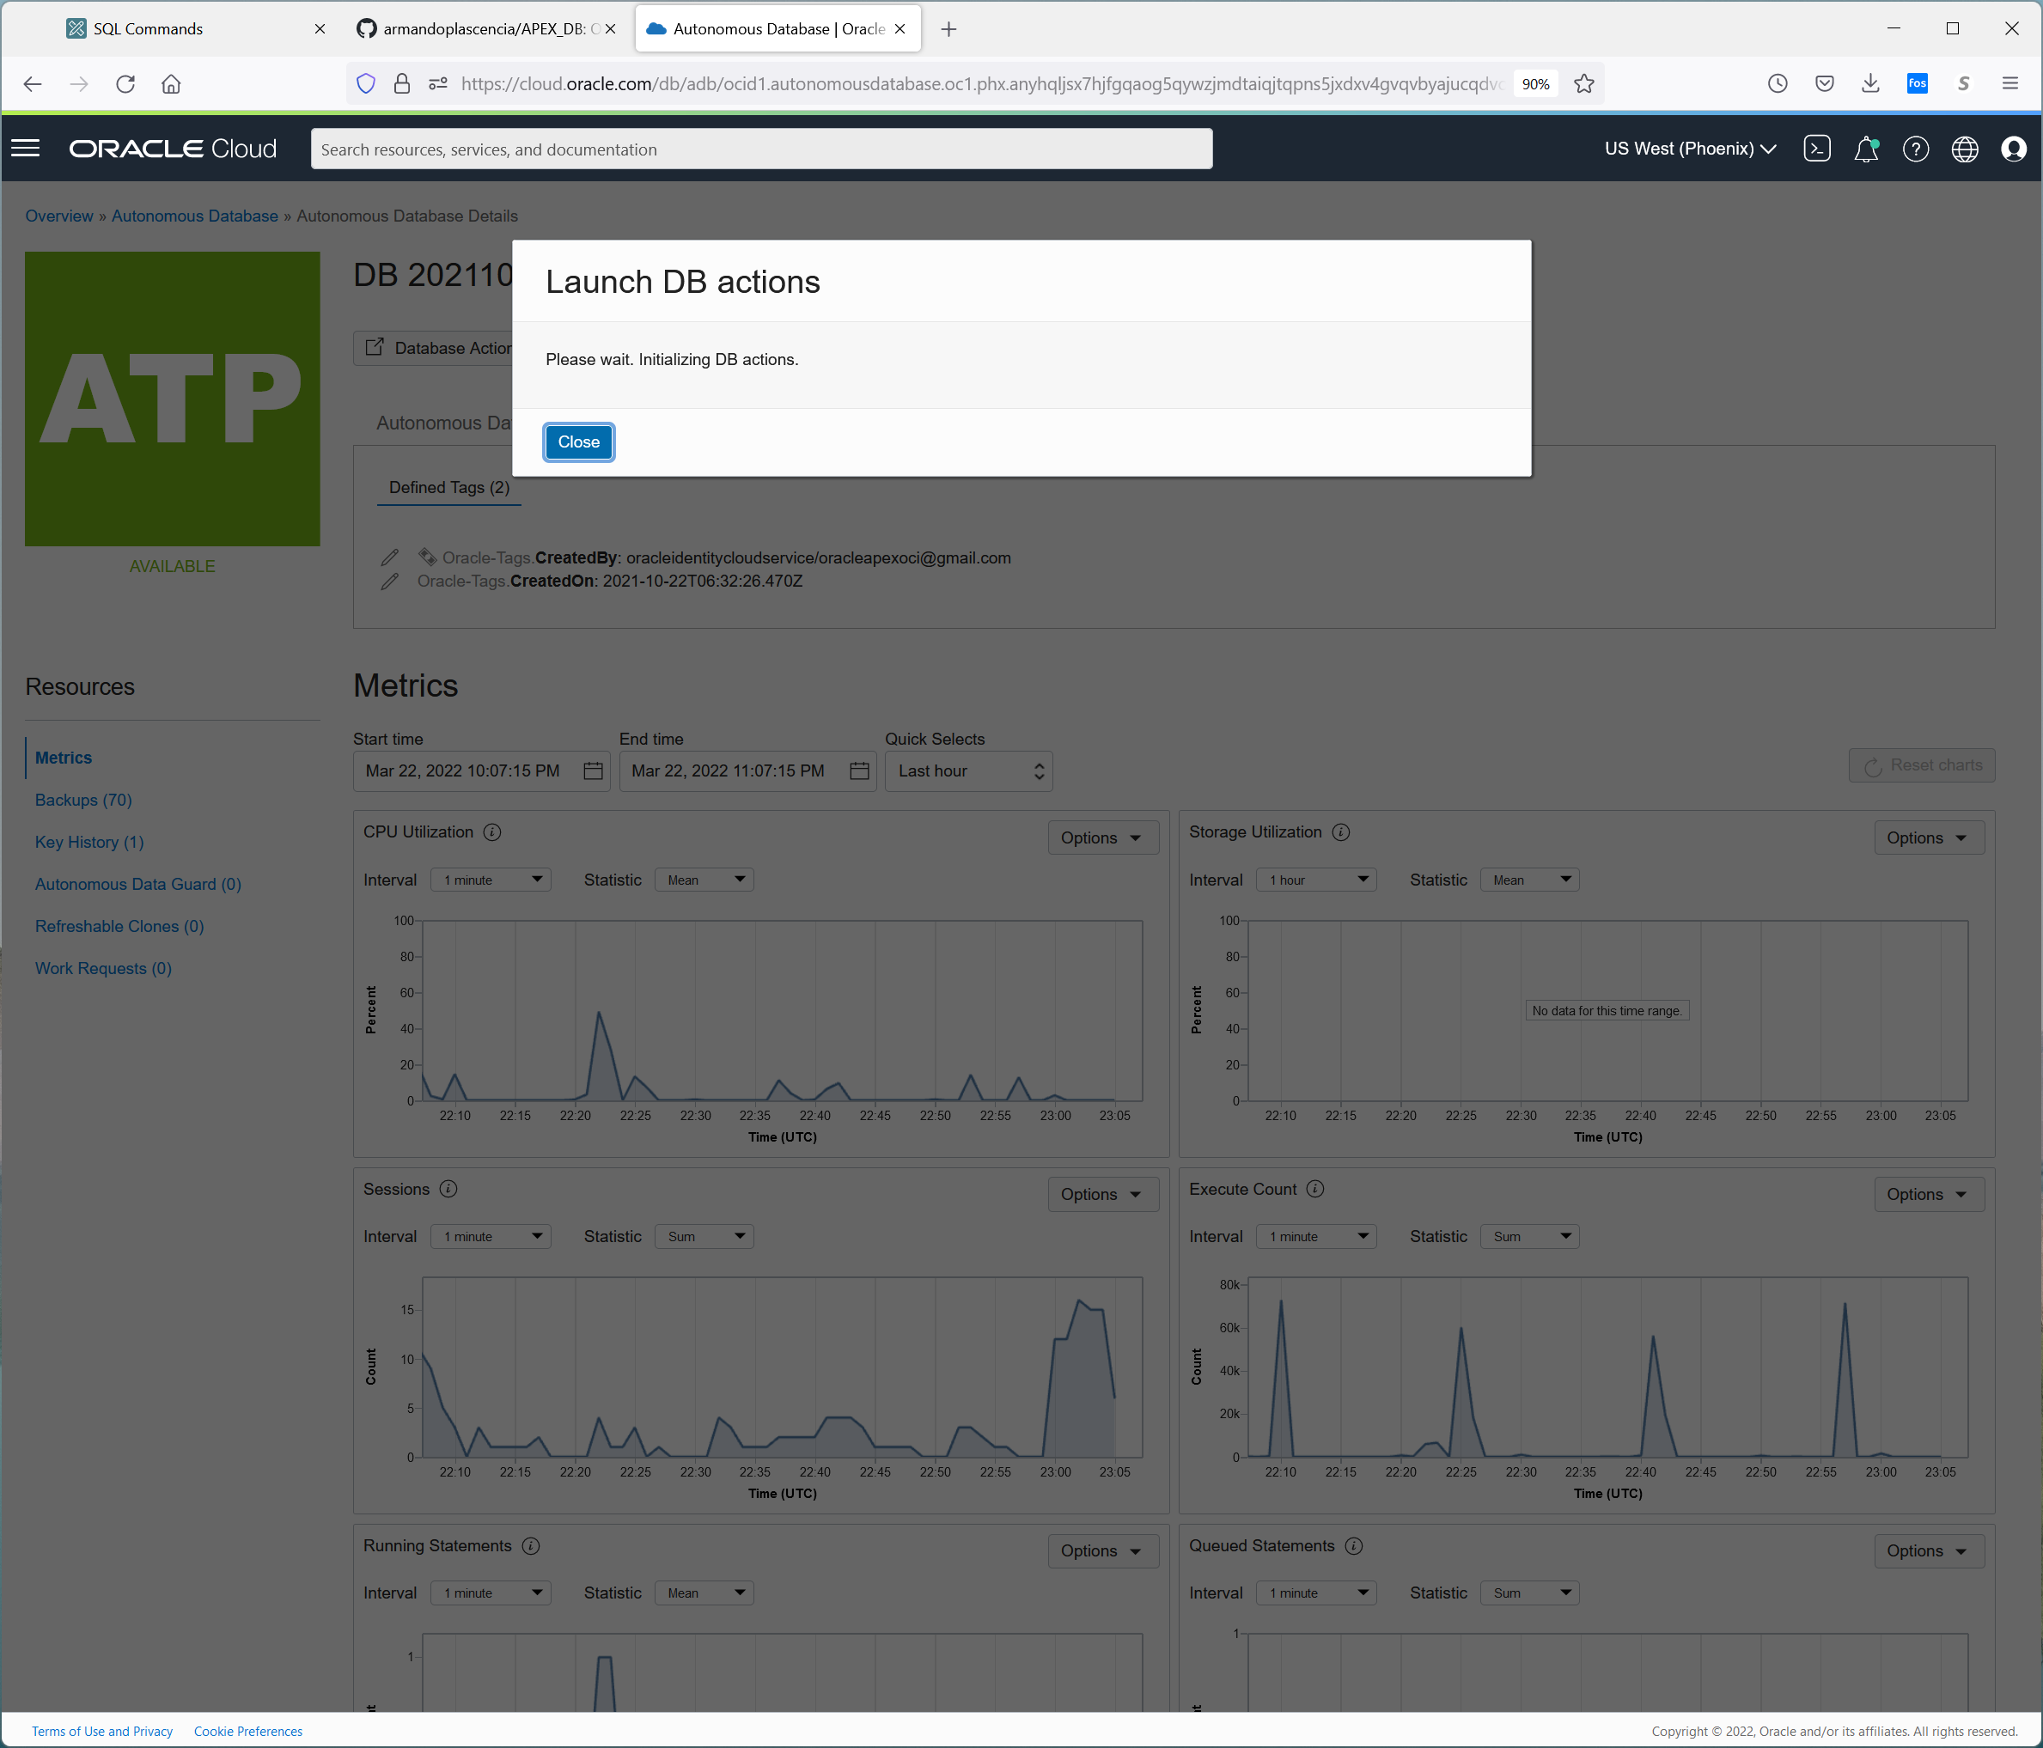

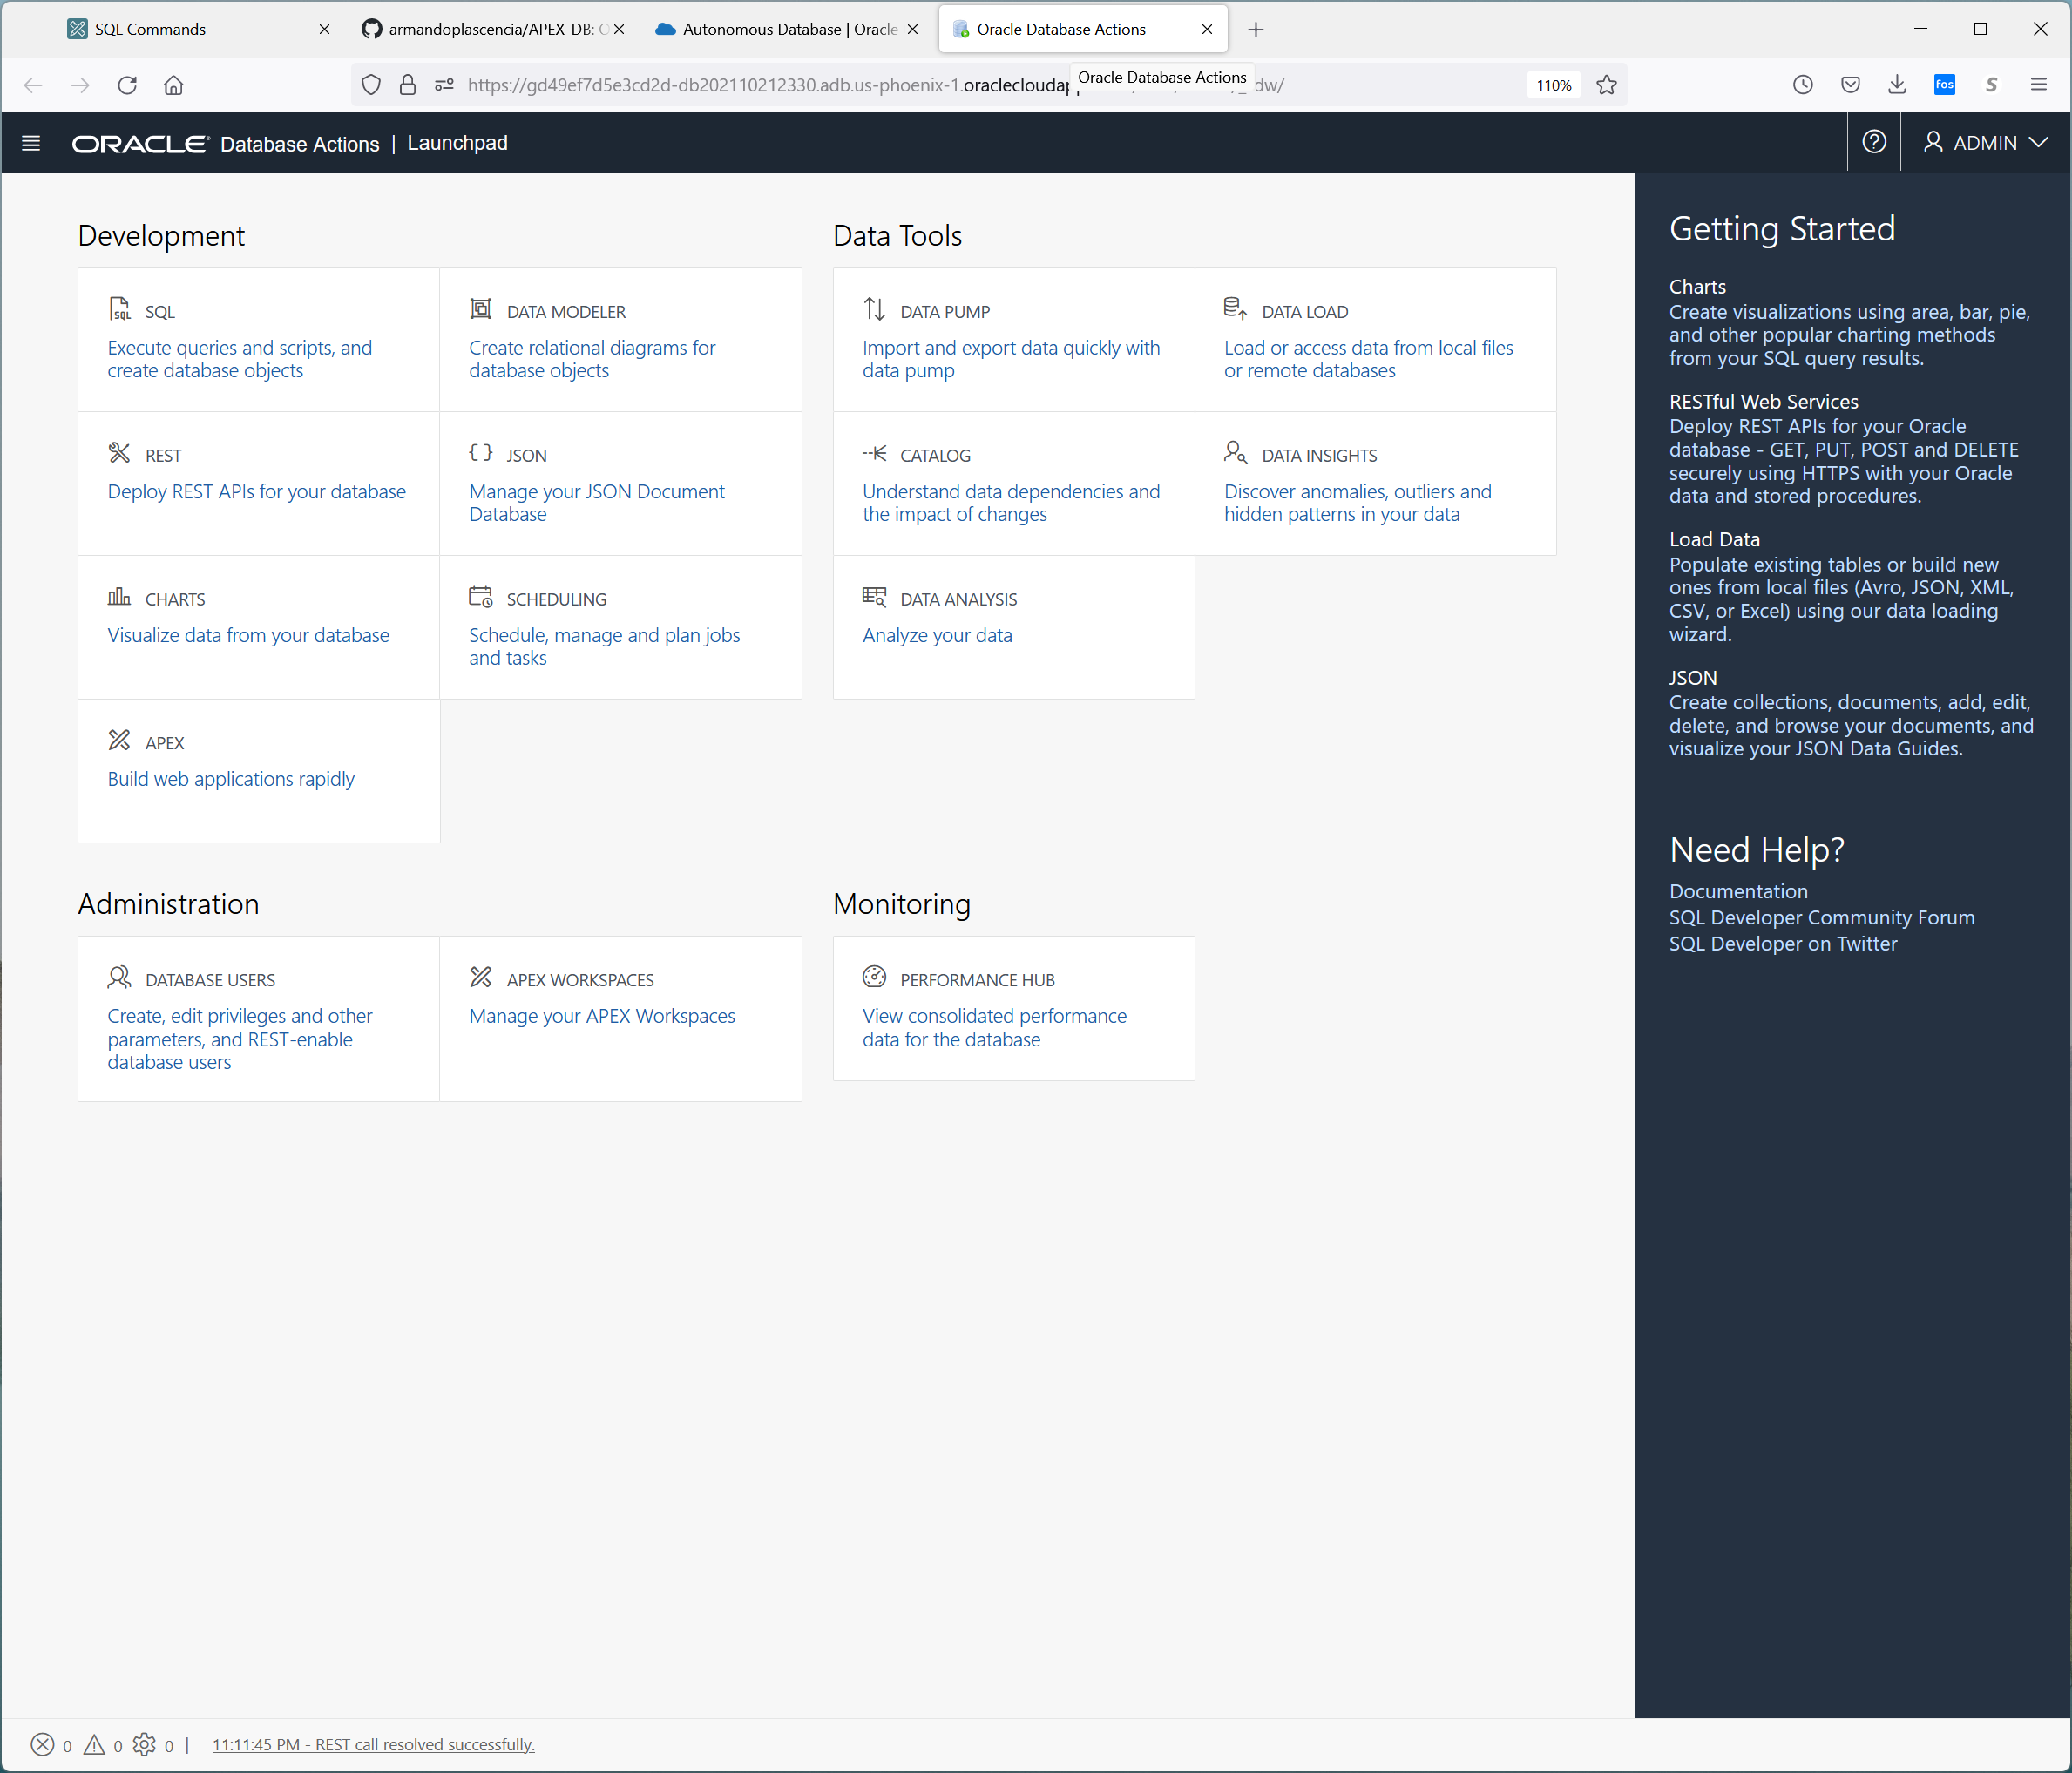

You have access to the data modeler , all compute functionality.

For the most part you will use SQL , DATA MODELER, SCHEDULER, REST and APEX.

For POS Access “REST Deploy Rest APIs for your database”

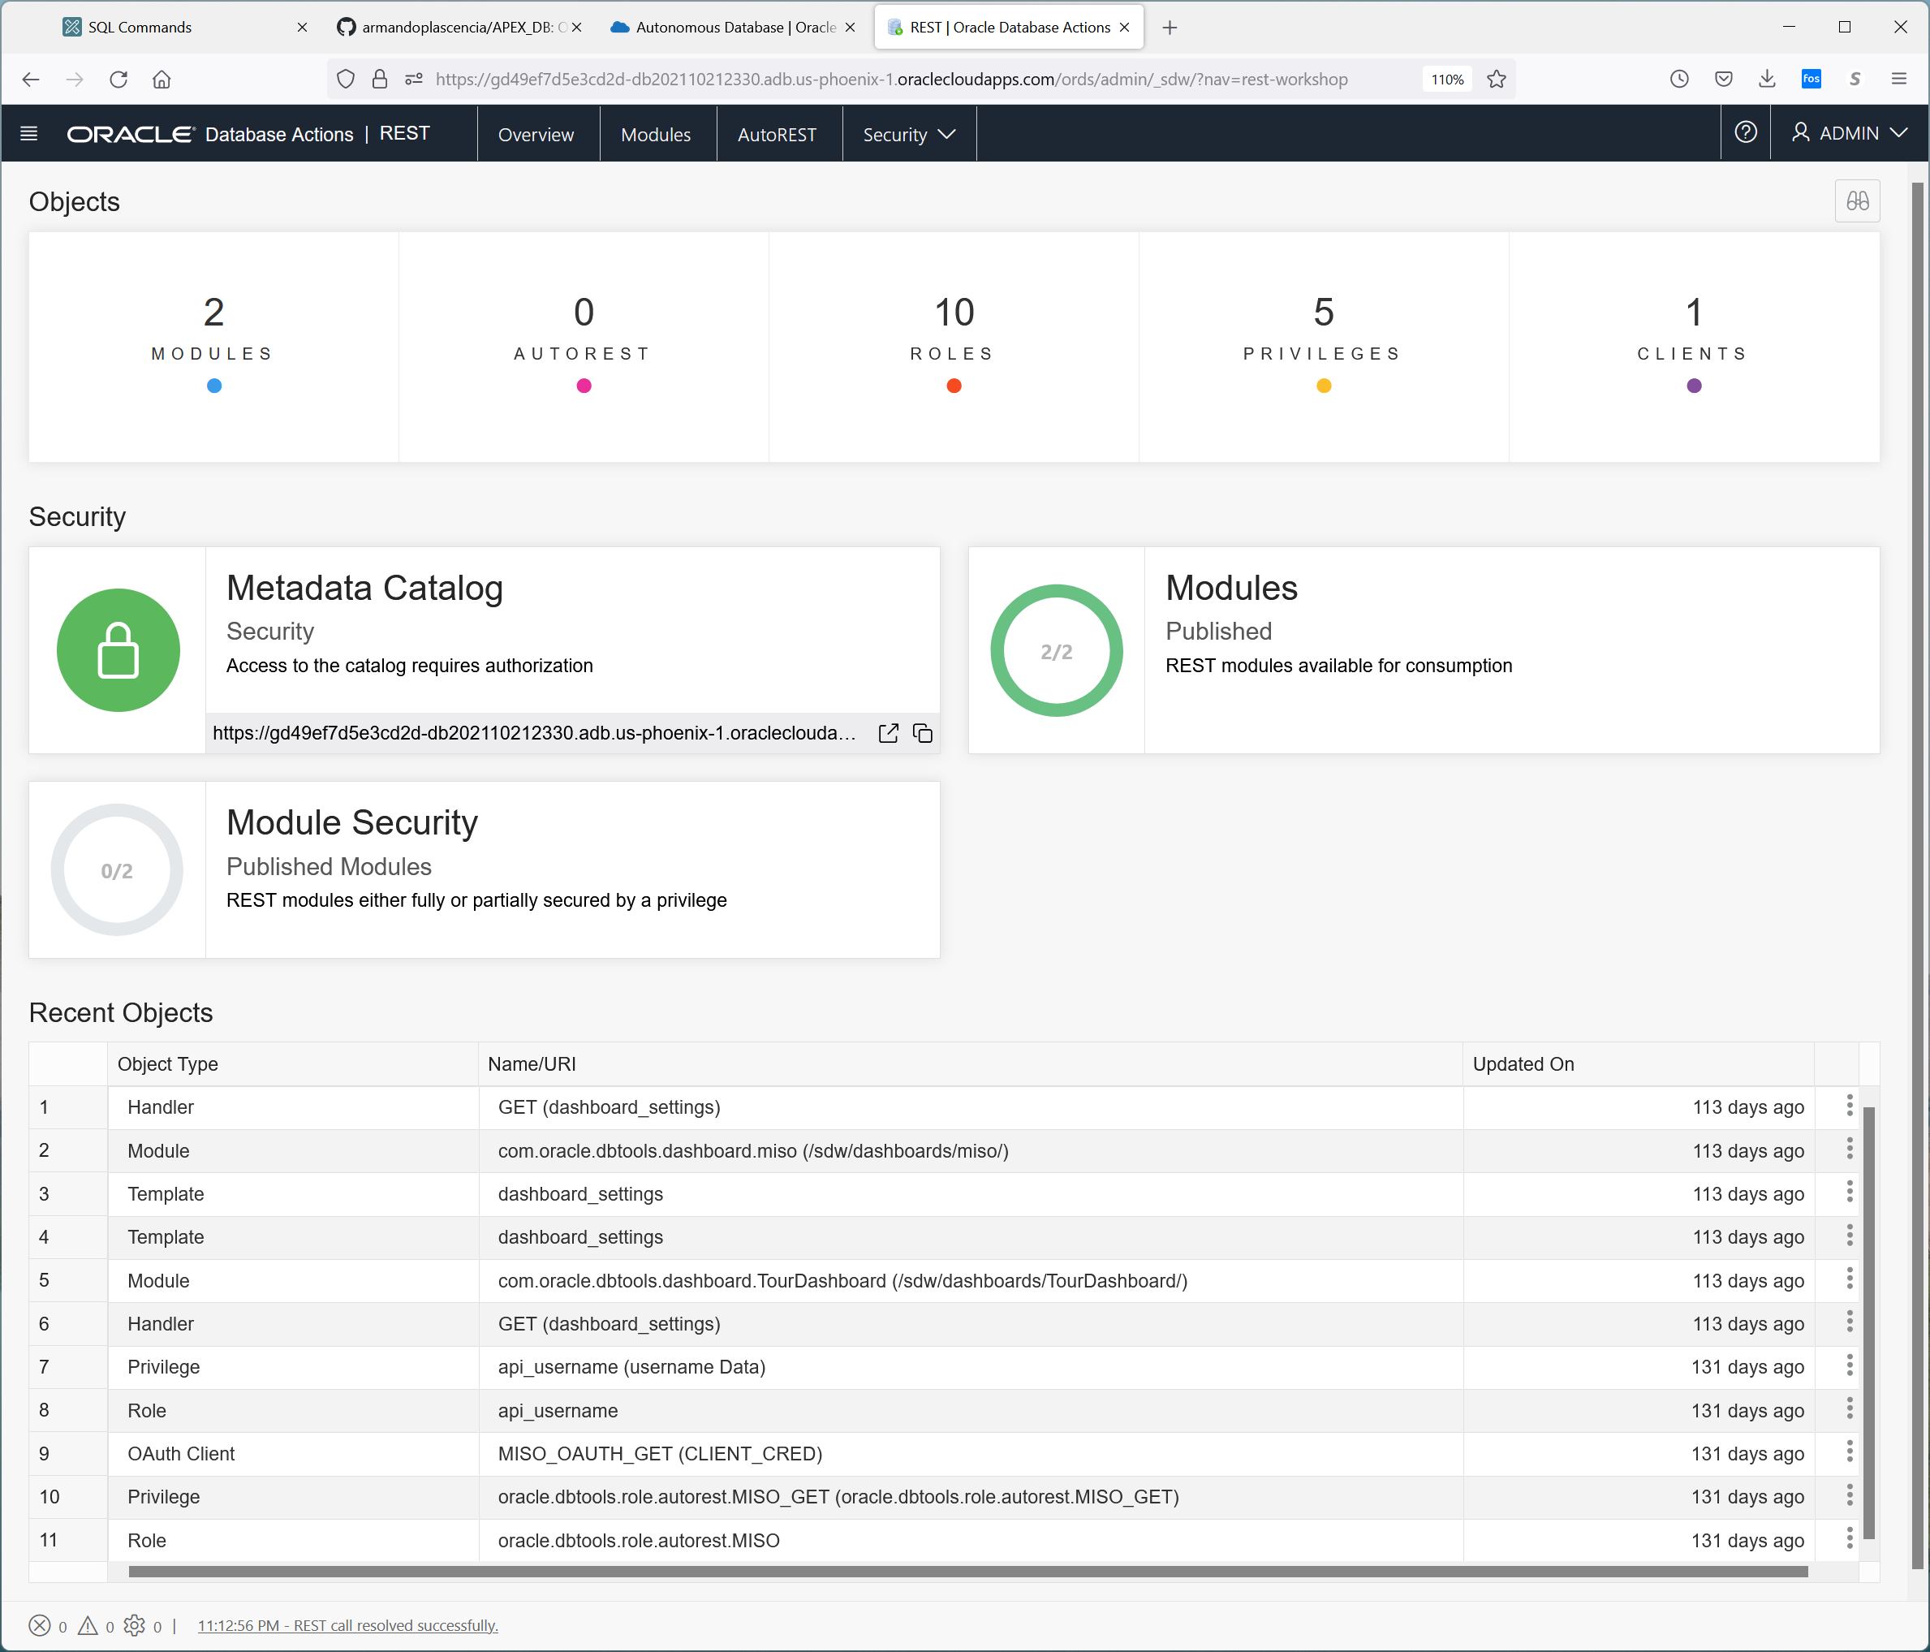

There are two logins

Admin/Admin

And Miso/Miso

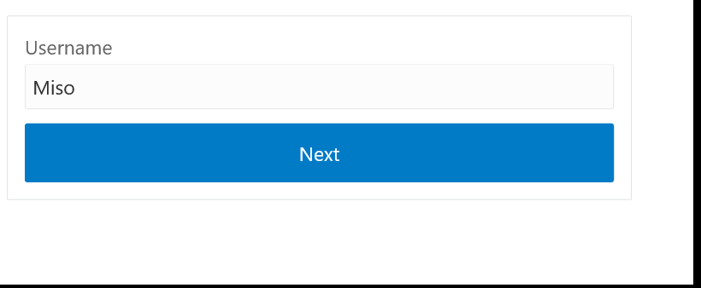

Password is Epfy44yqE_WEB

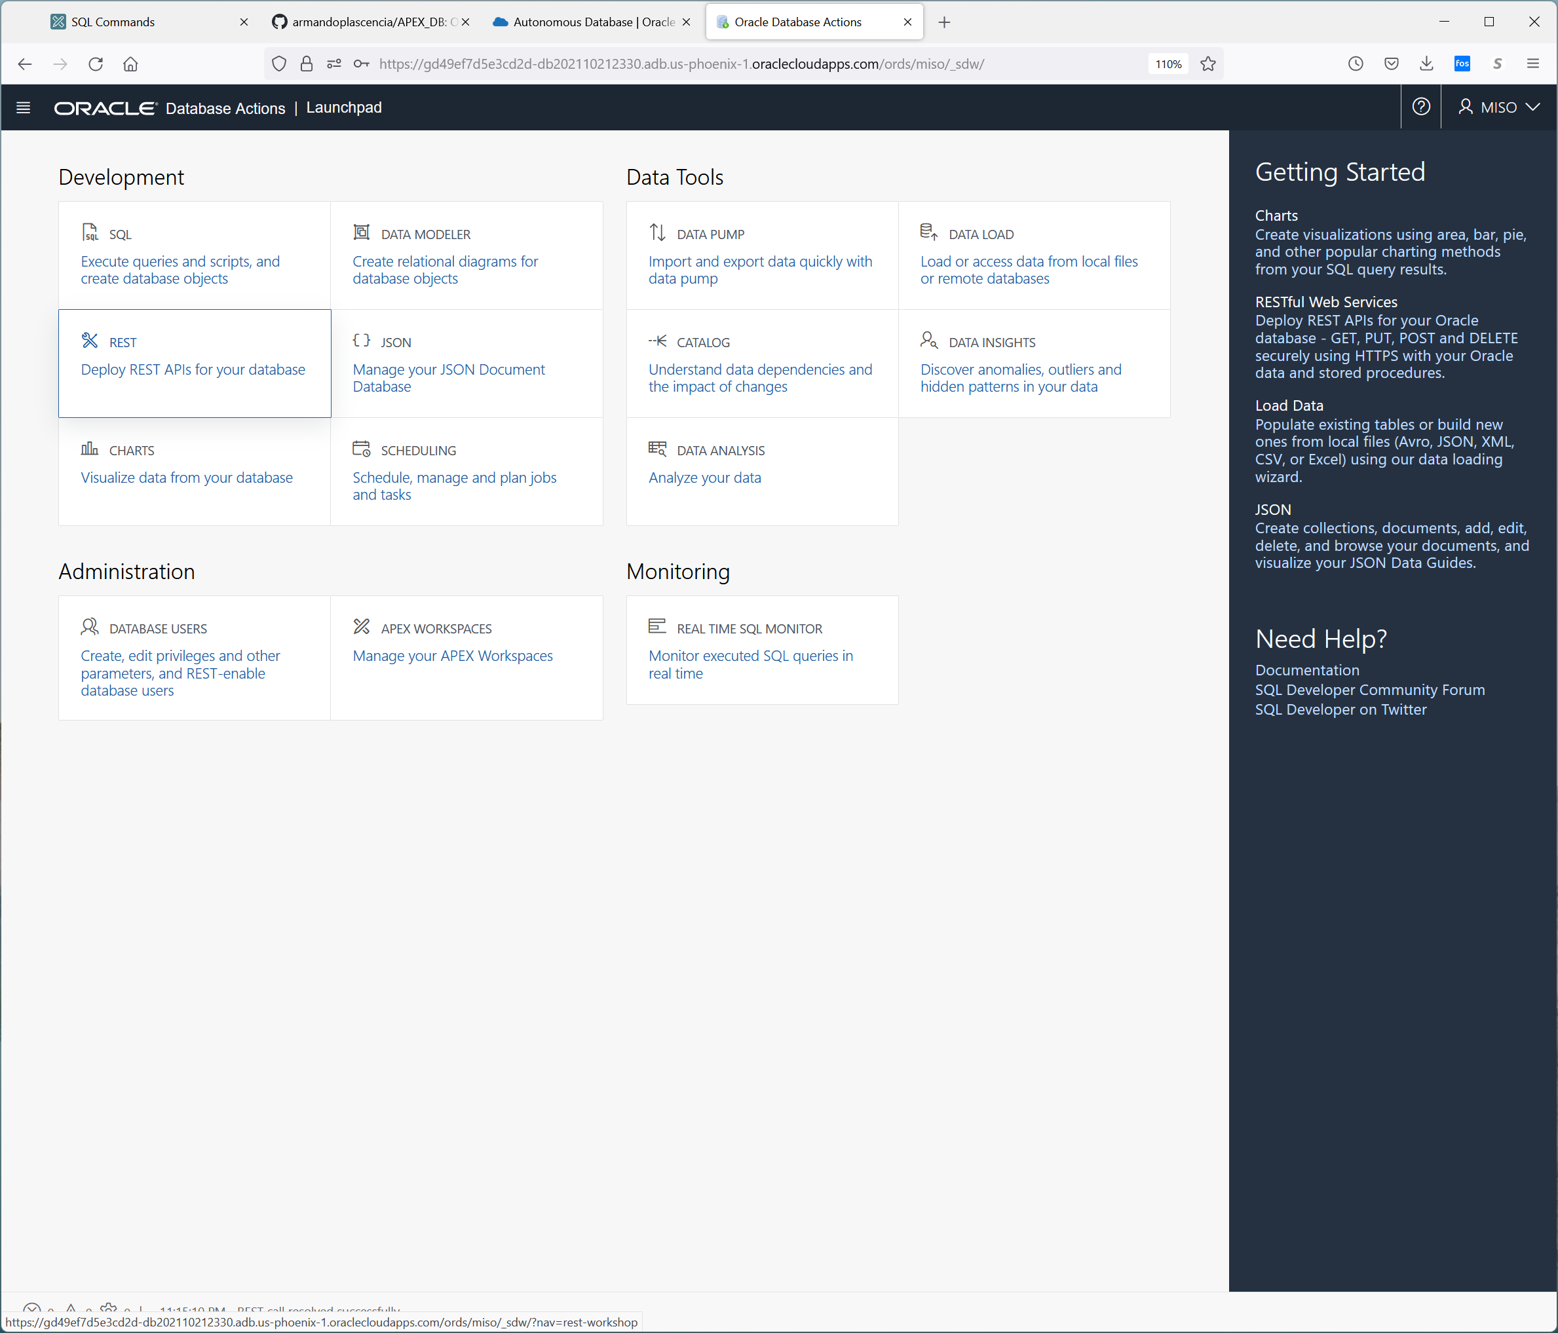

Note the user changed from admin to miso

The admin password is Epfy44yqE_WEB

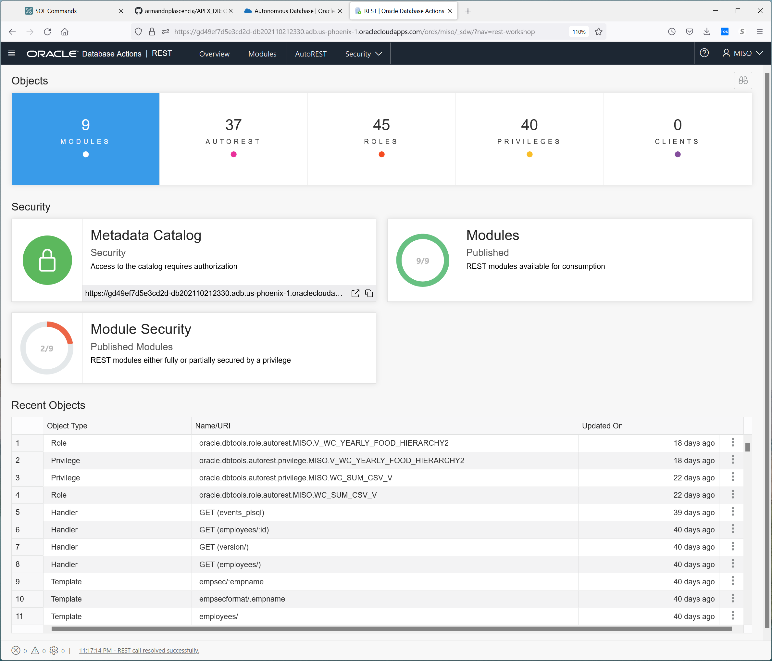

Select modules

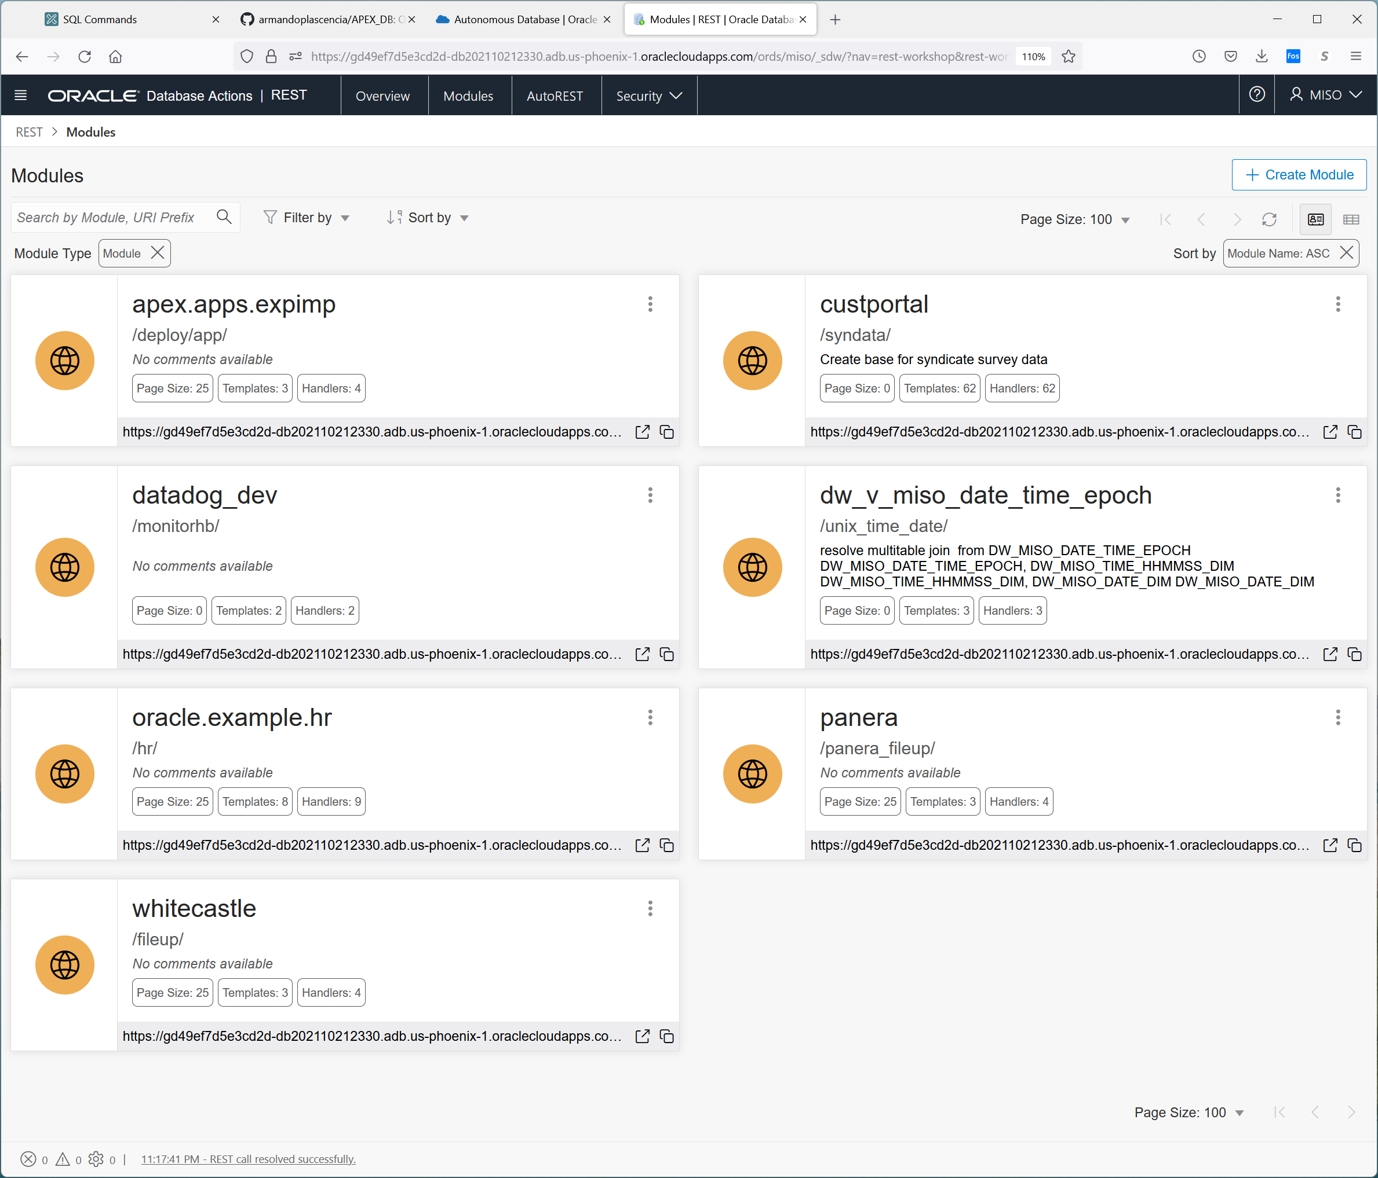

Select White Castle

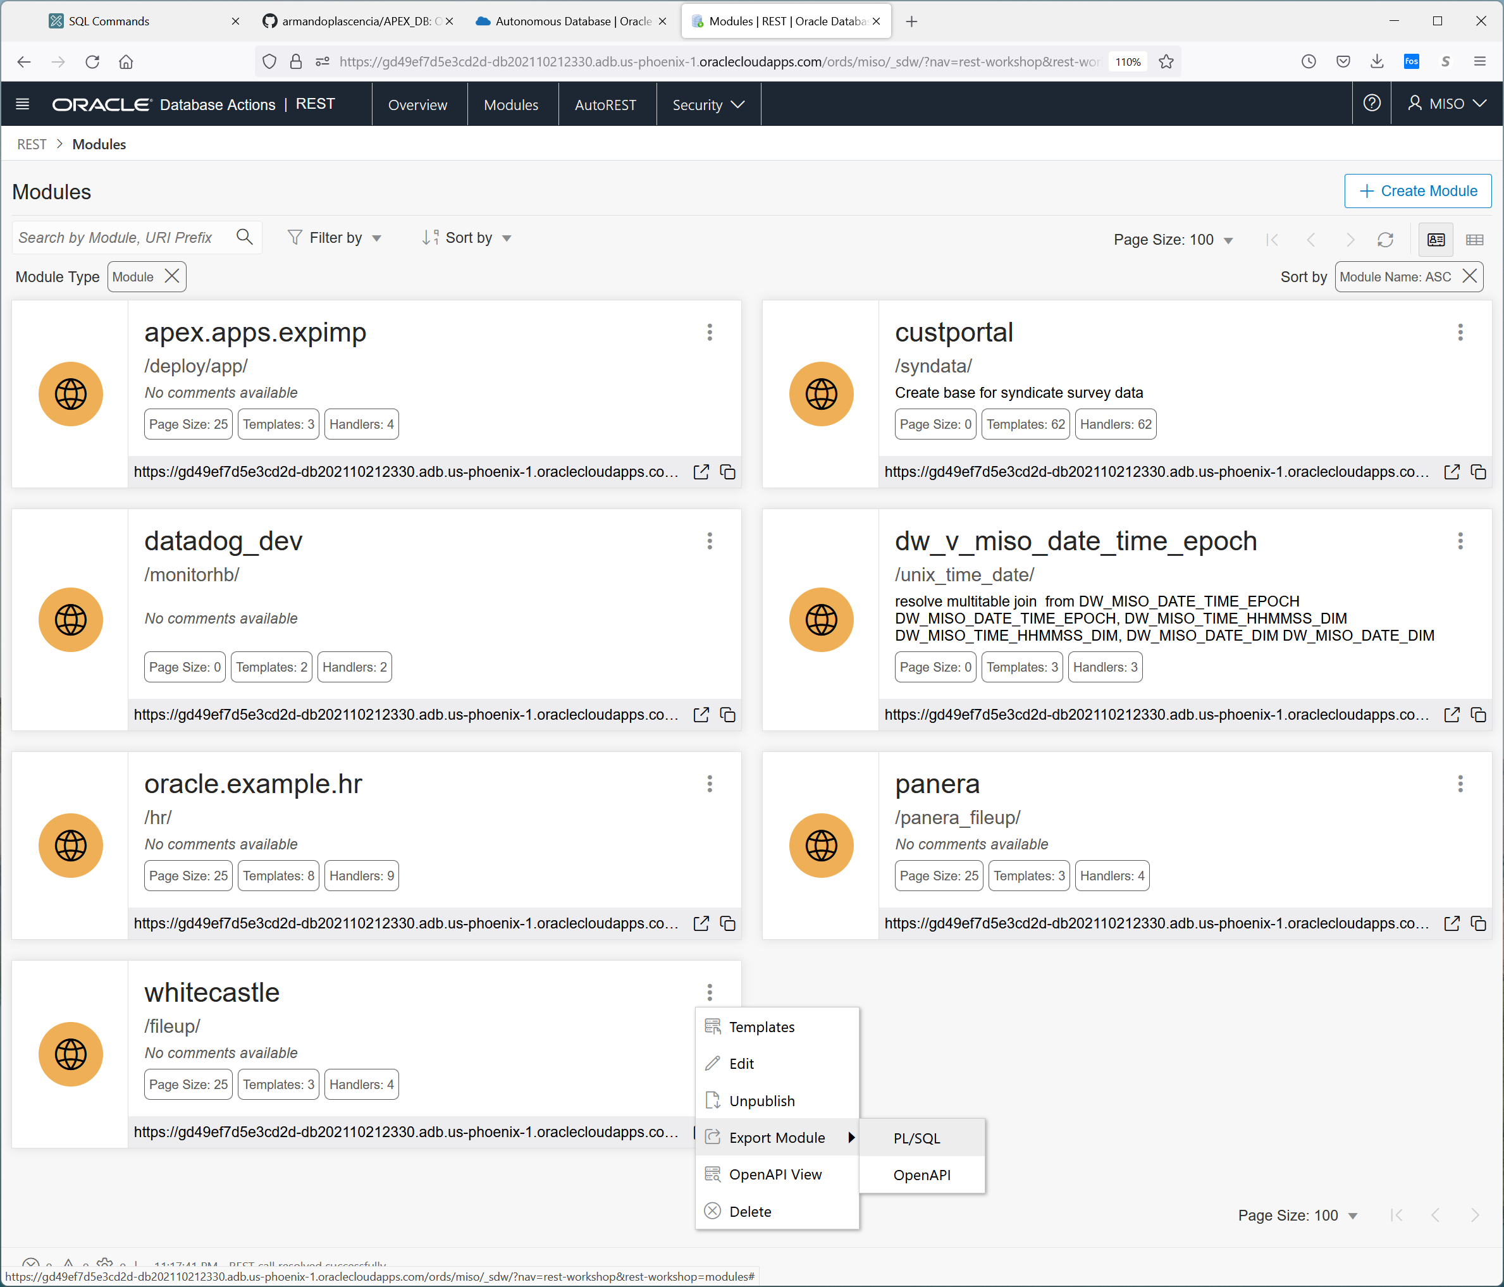

Under templates are the api’s that support white castle.

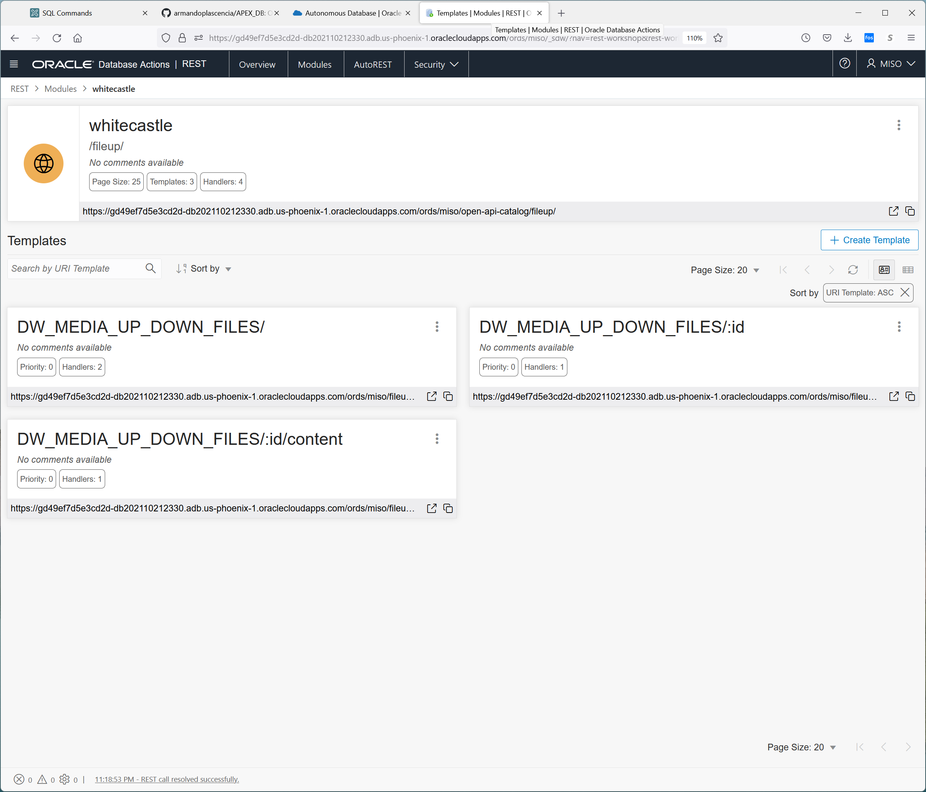

For the push of files from White Castle we have

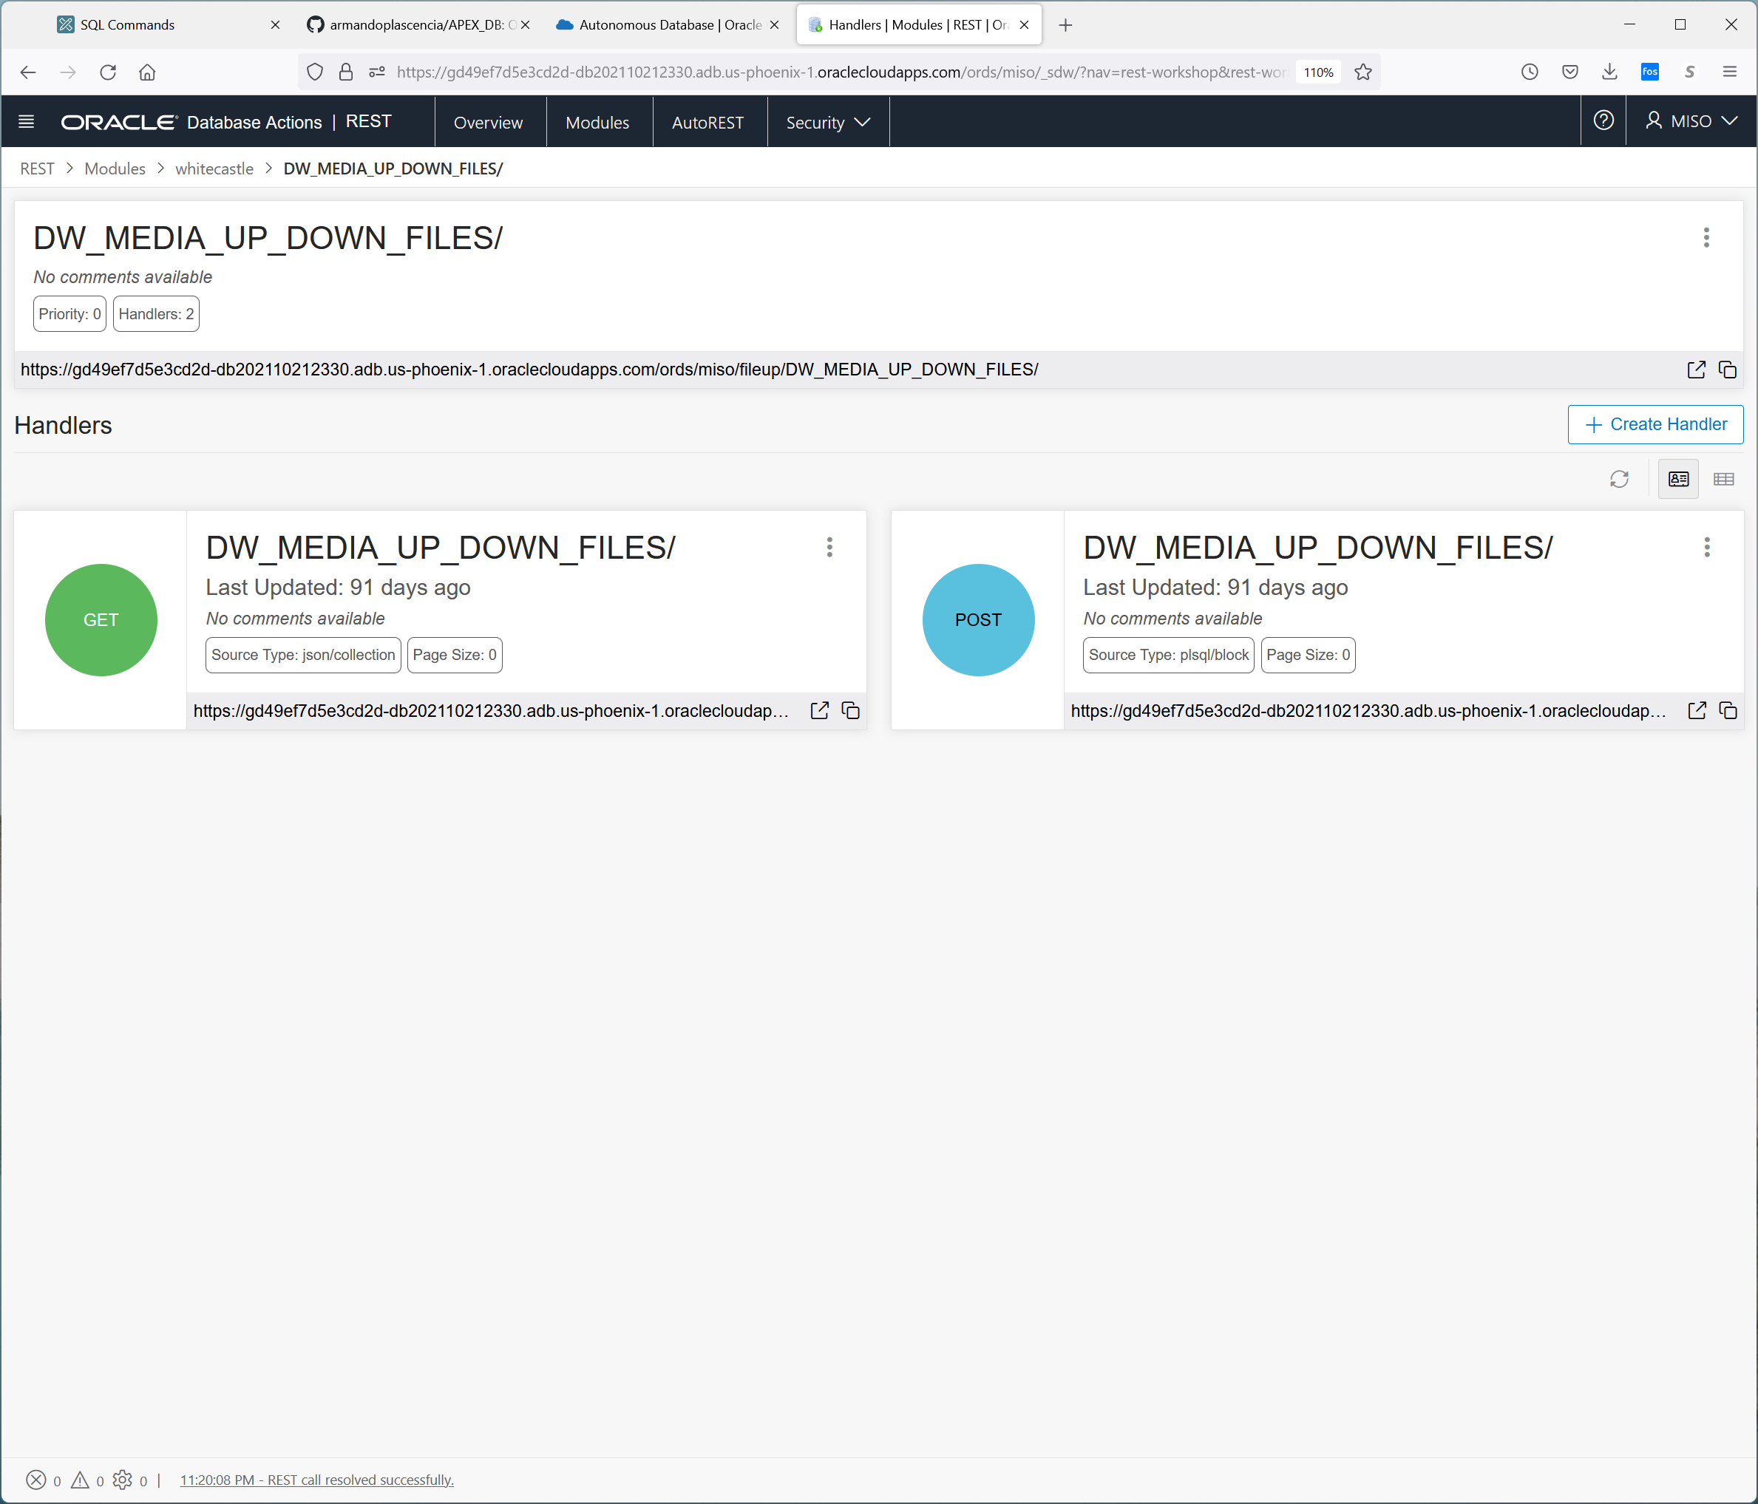

If you click on get

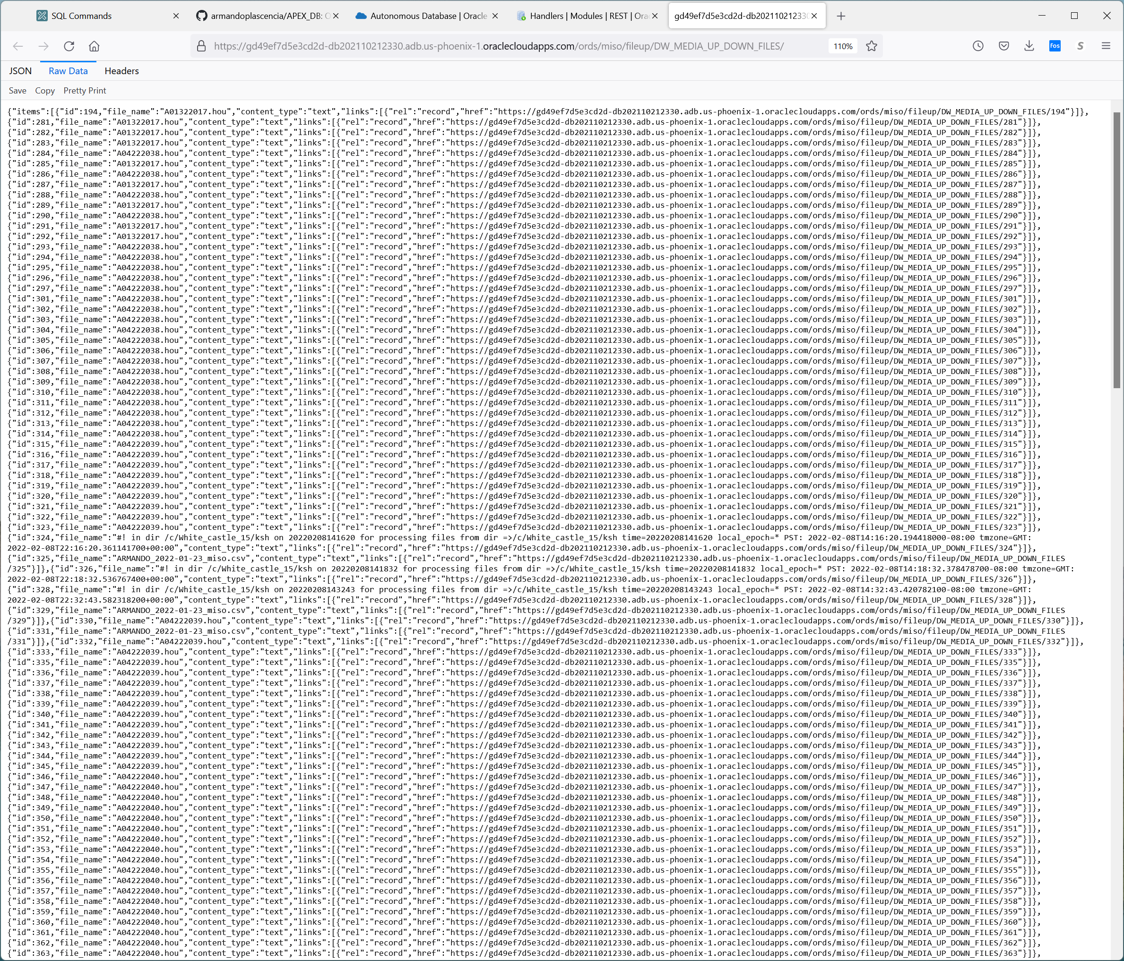

If you click on … the details are below:

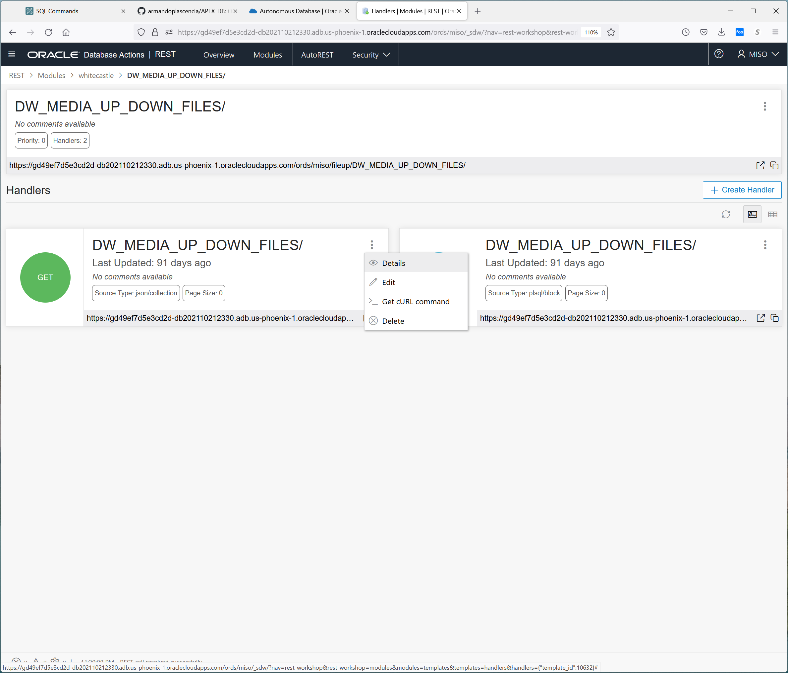

Here is the sql that is supporting the RESTAPI

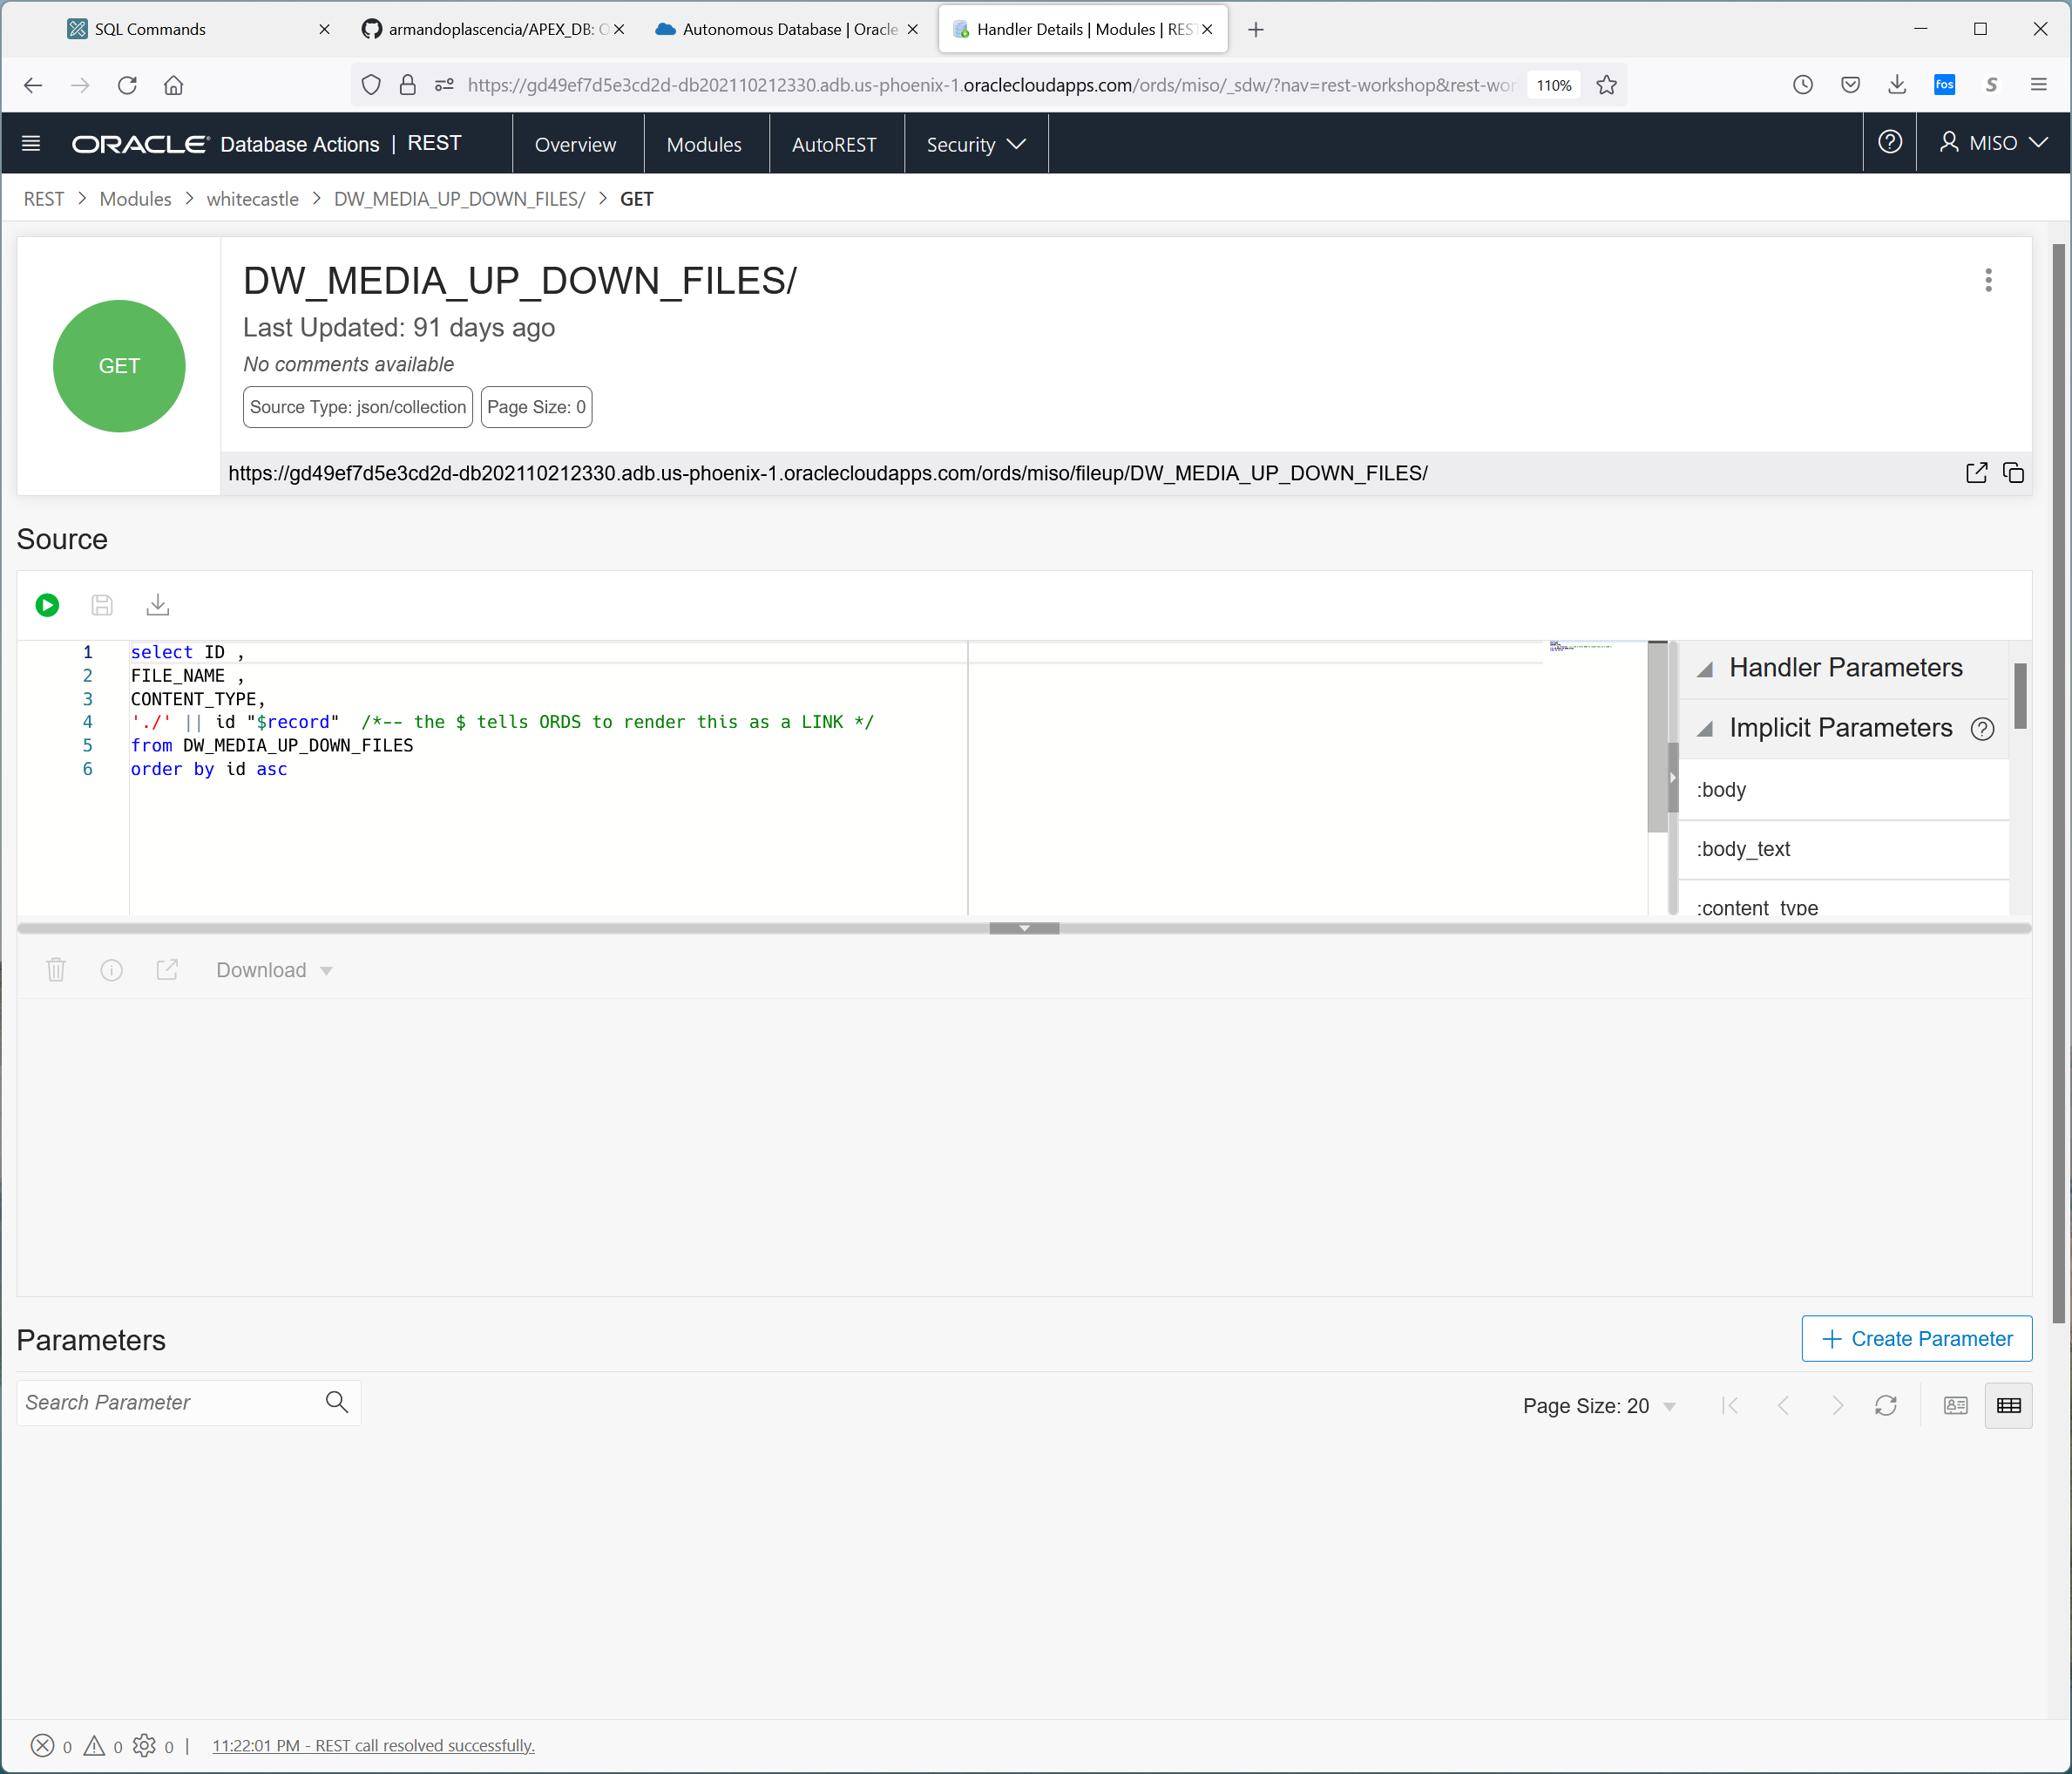

https://gd49ef7d5e3cd2d-db202110212330.adb.us-phoenix-1.oraclecloudapps.com/ords/miso/fileup/DW_MEDIA_UP_DOWN_FILES/

This returns the file info of whats In the table.

For POST , we get this.

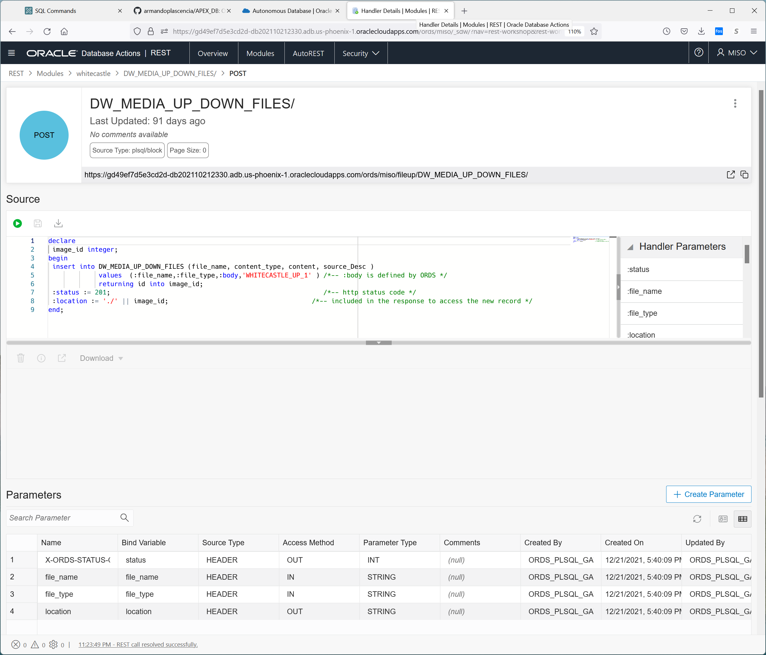

declare

 image_id integer;

begin

 insert into DW_MEDIA_UP_DOWN_FILES (file_name, content_type, content, source_Desc )

             values  (:file_name,:file_type,:body,'WHITECASTLE_UP_1' ) /*-- :body is defined by ORDS */

             returning id into image_id;

 :status := 201;                                                       /*-- http status code */

 :location := './' || image_id;                                     /*-- included in the response to access the new record */

end;

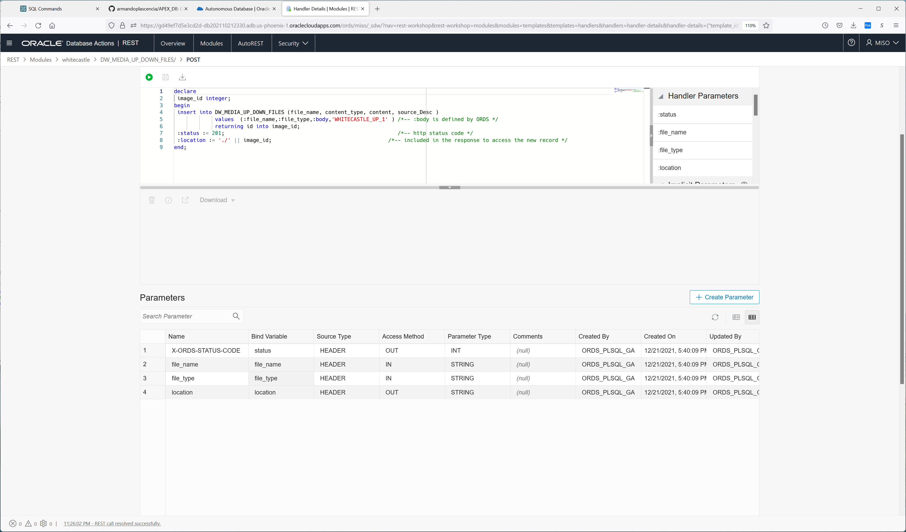

If we go to the header

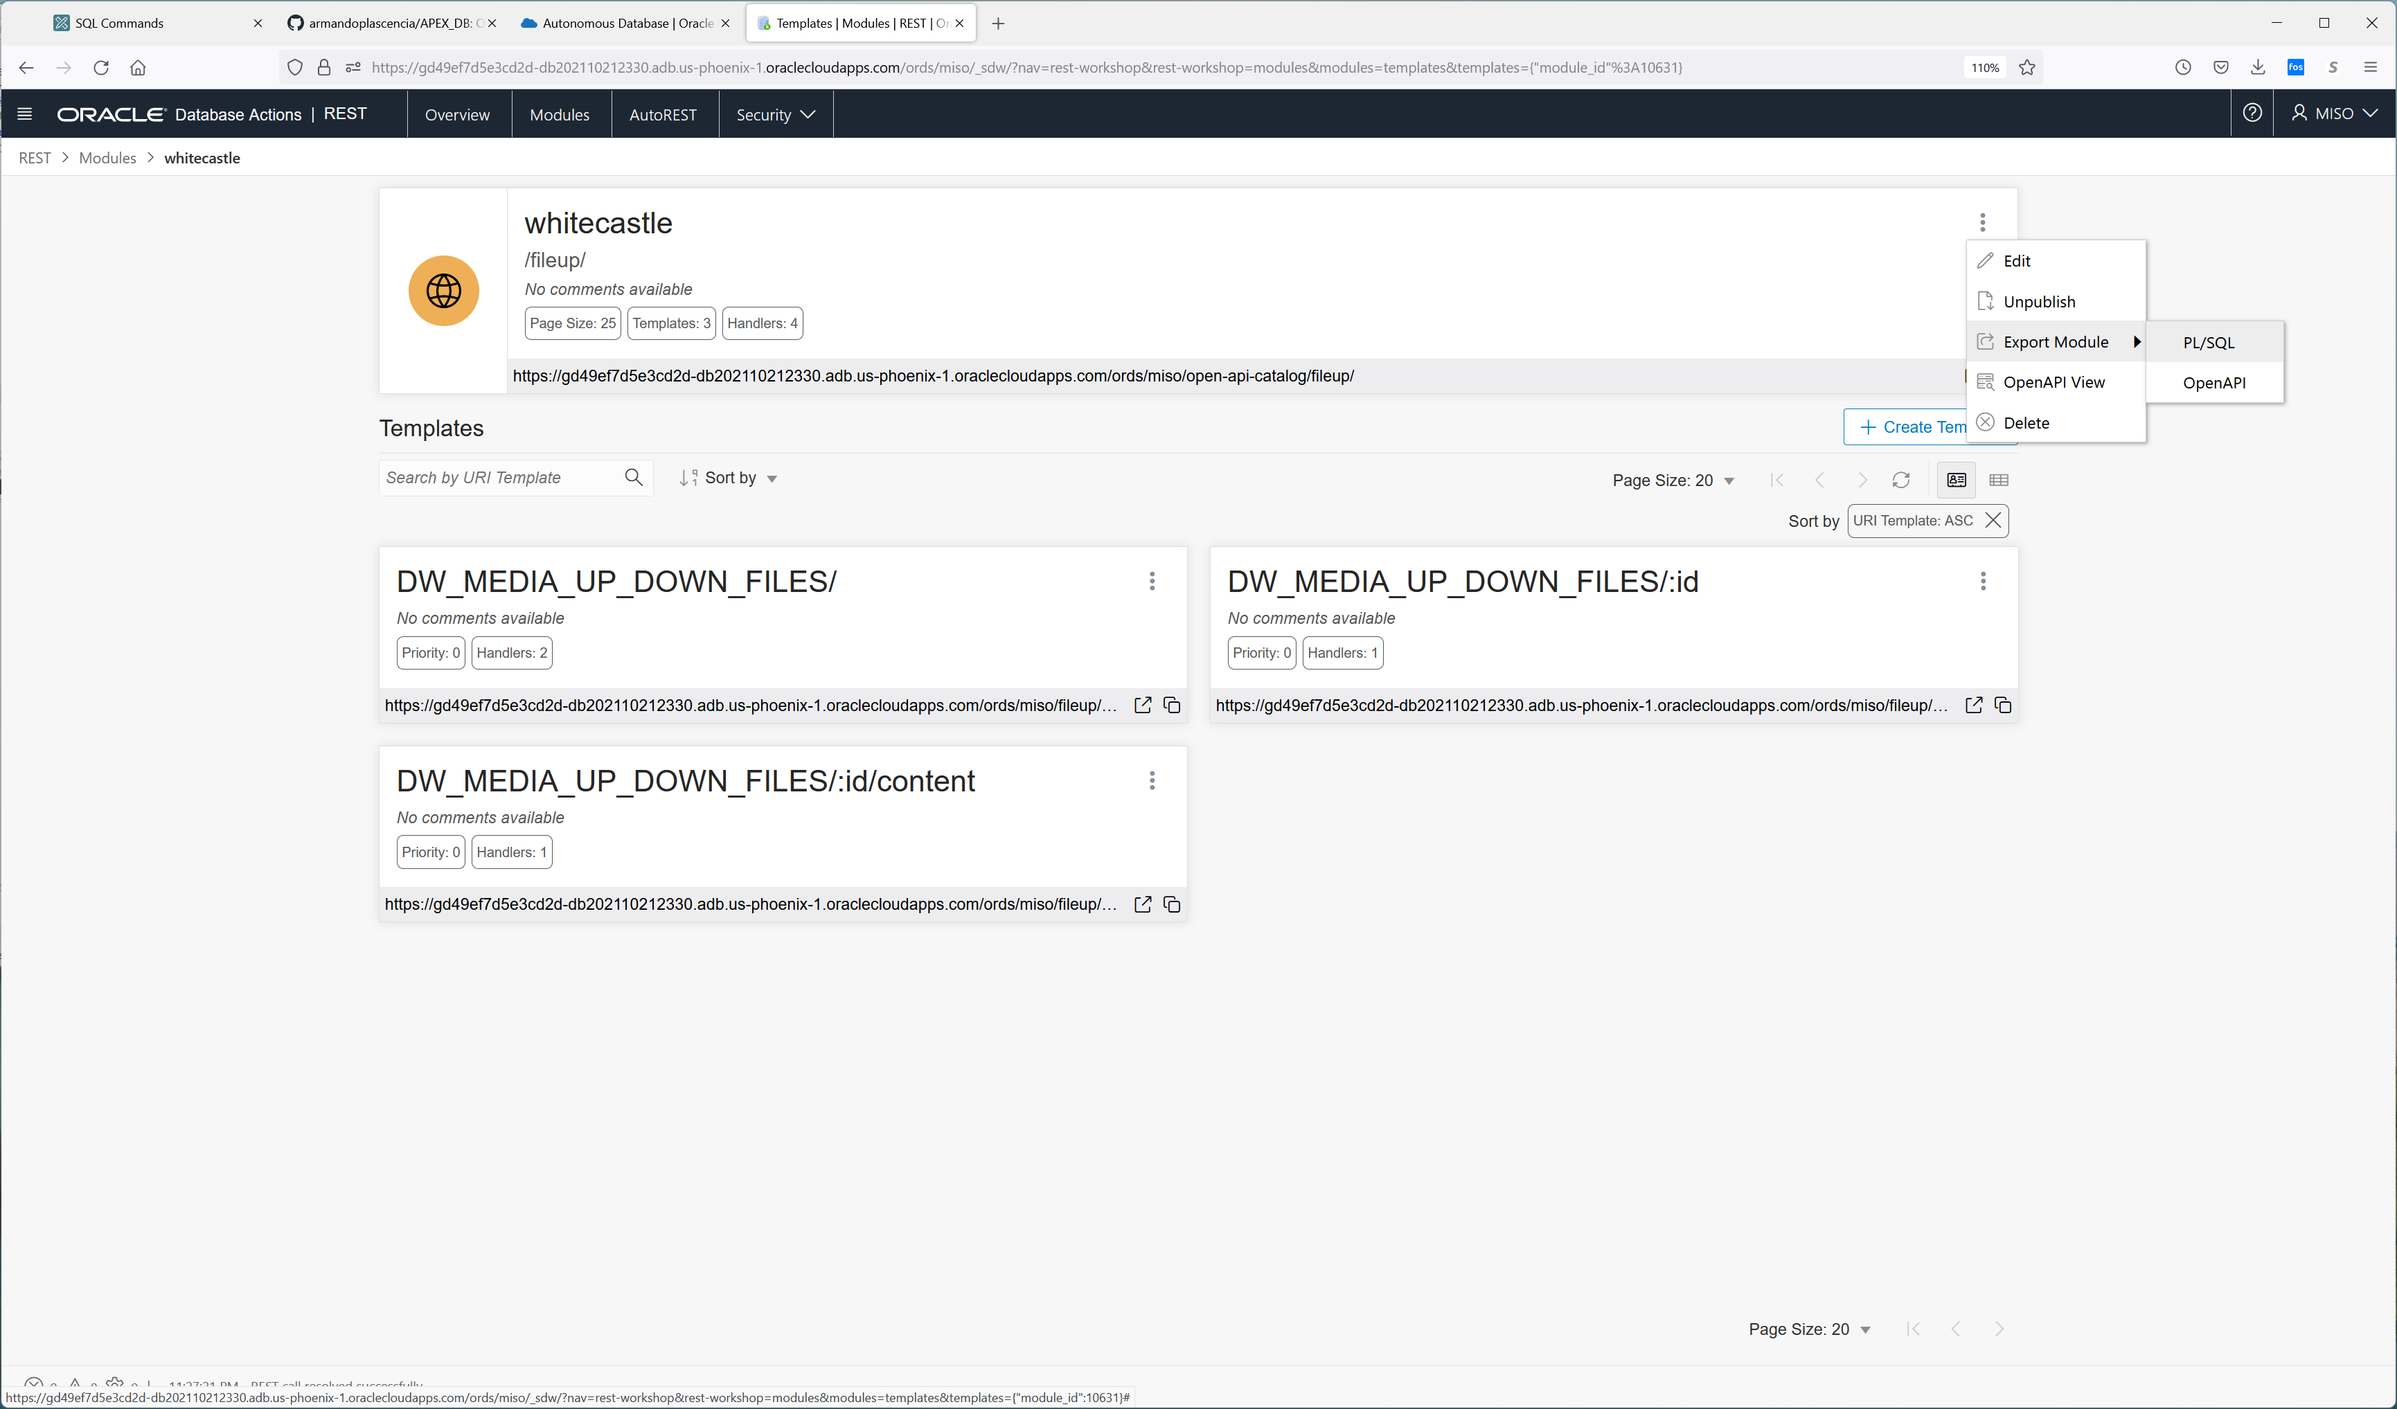

And extract the plsql we get what created the restapi.

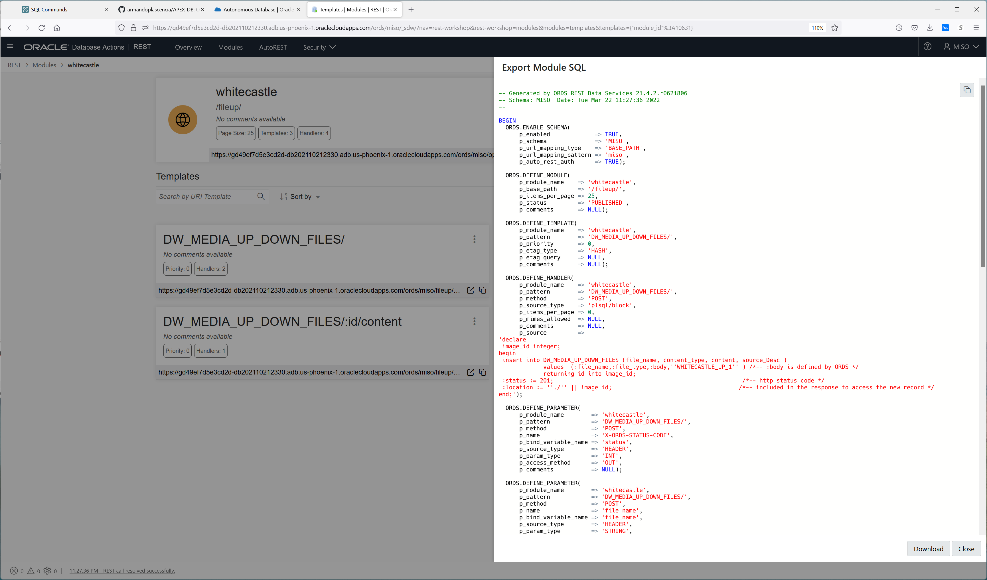

-- Generated by ORDS REST Data Services 21.4.2.r0621806

-- Schema: MISO Date: Tue Mar 22 11:27:36 2022

--

BEGIN

ORDS.ENABLE_SCHEMA(

p_enabled => TRUE,

p_schema => 'MISO',

p_url_mapping_type => 'BASE_PATH',

p_url_mapping_pattern => 'miso',

p_auto_rest_auth => TRUE);

ORDS.DEFINE_MODULE(

p_module_name => 'whitecastle',

p_base_path => '/fileup/',

p_items_per_page => 25,

p_status => 'PUBLISHED',

p_comments => NULL);

ORDS.DEFINE_TEMPLATE(

p_module_name => 'whitecastle',

p_pattern => 'DW_MEDIA_UP_DOWN_FILES/',

p_priority => 0,

p_etag_type => 'HASH',

p_etag_query => NULL,

p_comments => NULL);

ORDS.DEFINE_HANDLER(

p_module_name => 'whitecastle',

p_pattern => 'DW_MEDIA_UP_DOWN_FILES/',

p_method => 'POST',

p_source_type => 'plsql/block',

p_items_per_page => 0,

p_mimes_allowed => NULL,

p_comments => NULL,

p_source =>

'declare

image_id integer;

begin

insert into DW_MEDIA_UP_DOWN_FILES (file_name, content_type, content, source_Desc )

values (:file_name,:file_type,:body,''WHITECASTLE_UP_1'' ) /*-- :body is defined by ORDS */

returning id into image_id;

:status := 201; /*-- http status code */

:location := ''./'' || image_id; /*-- included in the response to access the new record */

end;');

ORDS.DEFINE_PARAMETER(

p_module_name => 'whitecastle',

p_pattern => 'DW_MEDIA_UP_DOWN_FILES/',

p_method => 'POST',

p_name => 'X-ORDS-STATUS-CODE',

p_bind_variable_name => 'status',

p_source_type => 'HEADER',

p_param_type => 'INT',

p_access_method => 'OUT',

p_comments => NULL);

ORDS.DEFINE_PARAMETER(

p_module_name => 'whitecastle',

p_pattern => 'DW_MEDIA_UP_DOWN_FILES/',

p_method => 'POST',

p_name => 'file_name',

p_bind_variable_name => 'file_name',

p_source_type => 'HEADER',

p_param_type => 'STRING',

p_access_method => 'IN',

p_comments => NULL);

ORDS.DEFINE_PARAMETER(

p_module_name => 'whitecastle',

p_pattern => 'DW_MEDIA_UP_DOWN_FILES/',

p_method => 'POST',

p_name => 'file_type',

p_bind_variable_name => 'file_type',

p_source_type => 'HEADER',

p_param_type => 'STRING',

p_access_method => 'IN',

p_comments => NULL);

ORDS.DEFINE_PARAMETER(

p_module_name => 'whitecastle',

p_pattern => 'DW_MEDIA_UP_DOWN_FILES/',

p_method => 'POST',

p_name => 'location',

p_bind_variable_name => 'location',

p_source_type => 'HEADER',

p_param_type => 'STRING',

p_access_method => 'OUT',

p_comments => NULL);

ORDS.DEFINE_HANDLER(

p_module_name => 'whitecastle',

p_pattern => 'DW_MEDIA_UP_DOWN_FILES/',

p_method => 'GET',

p_source_type => 'json/collection',

p_items_per_page => 0,

p_mimes_allowed => NULL,

p_comments => NULL,

p_source =>

'select ID ,

FILE_NAME ,

CONTENT_TYPE,

''./'' || id "$record" /*-- the $ tells ORDS to render this as a LINK */

from DW_MEDIA_UP_DOWN_FILES

order by id asc');

ORDS.DEFINE_TEMPLATE(

p_module_name => 'whitecastle',

p_pattern => 'DW_MEDIA_UP_DOWN_FILES/:id',

p_priority => 0,

p_etag_type => 'HASH',

p_etag_query => NULL,

p_comments => NULL);

ORDS.DEFINE_HANDLER(

p_module_name => 'whitecastle',

p_pattern => 'DW_MEDIA_UP_DOWN_FILES/:id',

p_method => 'GET',

p_source_type => 'json/item',

p_items_per_page => 25,

p_mimes_allowed => NULL,

p_comments => NULL,

p_source =>

'select FILE_NAME,

CONTENT_TYPE,

ID || ''/content'' "$file"

from DW_MEDIA_UP_DOWN_FILES

where ID = :id');

ORDS.DEFINE_TEMPLATE(

p_module_name => 'whitecastle',

p_pattern => 'DW_MEDIA_UP_DOWN_FILES/:id/content',

p_priority => 0,

p_etag_type => 'HASH',

p_etag_query => NULL,

p_comments => NULL);

ORDS.DEFINE_HANDLER(

p_module_name => 'whitecastle',

p_pattern => 'DW_MEDIA_UP_DOWN_FILES/:id/content',

p_method => 'GET',

p_source_type => 'resource/lob',

p_items_per_page => 25,

p_mimes_allowed => NULL,

p_comments => NULL,

p_source =>

'select CONTENT_TYPE,

CONTENT

from DW_MEDIA_UP_DOWN_FILES

where ID = :id');

COMMIT;

END;